

SHRI G.P.M. DEGREE COLLEGE OF SCIENCE & COMMERCE.

**SHRI G.P.M. DEGREE COLLEGE OF SCIENCE & COMMERCE**

(COMMITTED TO EXCELLENCE IN EDUCATION)

**CERTIFICATE**

This is to certify thar Mr/Ms Student of class BSc-IT [ Roll No: ] has completed the required number of

practical’s in the subject of Business-Intelligence as prescribed by the University of Mumbai under my supervision during the academic year 2023-2024.

Prof. In Charge Course Co-coordinator

External Examiner Principal

Date: College Seal

|  |  |
| --- | --- |
| **Prof. Name :** | **Class /SEM : T.Y. B.Sc. - IT / Sem – VI (2023-2024)** |
| **Course Code : USIT6P3** | **Subject Name : Business Intelligence** |

|  |  |  |  |
| --- | --- | --- | --- |
| **Date** | **INDEX** | **Pg.**  **No.** | **Sign.** |
|  | **Theory-1 : Loading**  **Practical-1:** Import the legacy data from different sources such as (Excel ,- SqlServer, Oracle etc.) and load in the target system. (You can download sample database such as Adventure works, North wind, food mart etc.) **(IT Lab)**  **Example-1:** Import the legacy data from different sources such as Excel. **(IT Lab)**  **Example-2:** Show Implementation of Classification algorithm in R -(**Homework)**  **Example -3:** Import the legacy data from different sources such as Sql Server. (**Homework) Practical-1:** Familiarizing Quantum GIS: Installation of QGIS, datasets for both Vectorand Raster data, Maps. **(IT Lab)** |  |  |
|  | **Theory-2: Extraction**  **Practical-2:** Perform the Extraction Transformation and Loading (ETL) -processto construct the database in the Sql server. **(IT Lab)**  **Example-1:** Perform the Extraction. **(IT Lab)**  **Example-2:** (A) Create the cube with suitable dimension and fact tables basedonROLAP, MOLAP and HOLAP model. (**Homework)**  **Example -3:** Perform Transformation. (**Homework)** |  |  |
|  | **Theory-3: Data staging**  **Practical-3:** a. Create the Data staging area for the selected database. b. Create the cube with suitable dimension and fact tables based on ROLAP, MOLAP and HOLAP model. **(IT Lab) Example-1:** Create the cube with suitable dimension and fact tables based on ROLAP.  **(IT Lab)**  **Example-2:** Perform the data clustering using clustering algorithm in RProgramming. (**Homework)**  **Example -3:** Create the cube with suitable dimension and fact tables based on MOLAP. (**Homework)** |  |  |
|  | **Theory-4: ETL**  **Practical-4:** a. Create the ETL map and setup the schedule for execution. –  b. Execute the MDX queries to extract the data from data ware house. **(IT Lab) Example-1:** Execute the MDX queries to extract th e data from the Excel. **(IT Lab) Example-2:** Perform the Linear regression on the given data warehouse data. (**Homework)**  **Example-3:** Execute the MDX queries to extract the data from the SQL. server.(**Homework)** |  |  |
|  | **Theory-5: Data ware house**  **Practical-5:** a. Import the data ware house data in Micros Excel and create thePivot table and PivotChart. b. Import the cube in Microsoft Excel and create- the Pivot table and Pivot Chart to perform data analysis. **(IT Lab)**  **Example-1:** Import the data ware house data in Microsoft Excel and create the Pivot table.  **(IT Lab)**  **Example-2:** Show prediction Using Linear Regression. (**Homework)**  **Example-3:** Import the data ware house data in Microsoft Excel and create- the PivotChart. (**Homework)** |  |  |
|  | **Theory-6: Data ware house data**  **Practical-6:** Apply the what – if Analysis for data visualization. Design and generate necessary reports based on the data ware house data. **(IT Lab)**  **Example-1:** Show waterfall graph on data in power bi**. (IT Lab)**  **Example-2:** perform the logistic regression on the given data warehouse data (**Homework)**  **Example-3:** Show use of table and matrix. (**Homework)** |  |  |

1/2

|  |  |  |  |
| --- | --- | --- | --- |
|  | **Theory-7: Classification**  **Practical-7:** Perform the data classification using classification algorithm **(IT Lab) Example-1:** Show use of slicer on data. **(IT Lab)**  **Example-2:** Perform the data clustering using clustering algorithm in R – Programing. (**Homework)**  **Example-3:** Use filters on data**.** (**Homework)** |  |  |
|  | **Theory-7: Classification**  **Practical-7:** Perform the data classification using classification algorithm **(IT Lab) Example-1:** Show use of slicer on data. **(IT Lab)**  **Example-2:** Perform the data clustering using clustering algorithm in R -Programing. (**Homework)**  **Example-3:** Use filters on data**.** (**Homework)** |  |  |
|  | **Theory-8: Clustering**  **Practical-8:** Perform the data clustering using clustering algorithm. **(IT Lab) Example-1:** Transform less structured data in power bi. **(IT Lab)**  **Example-2:** Use merge query in power bi. (**Homework)** |  |  |
|  | **Theory-9: Linear regression**  **Practical-9:** Perform the Linear regression on the given data ware house data.- **(IT Lab) Example-1:** Optimize models for reporting. **(IT Lab)**  **Example-2:** Show map visualization. (**Homework)** |  |  |
|  | **Theory-10: logistic regression**  **Practical-10:** Perform the logistic regression on the given data ware house -data.  **(IT Lab)**  **Example-1:** Perform ETL transformation on the above data by converting the attribute Name from lowercase to uppercase. **(IT Lab)**  **Example-2:** What is pinning on data set? **(IT Lab)**  **Example-3:** publish a report to the web from power bi. (**Homework)** |  |  |

2/2





**SHRI GPM DEGREE COLLEGE OF SCIENCE & COMMERCE**

Department of Computer

**Affiliated to University of Mumbai**

Vision.. Innovation.. Solution.. Presentation..



**Practical-1: Import the legacy data from different sources such as (Excel ,- Sql Server, Oracle etc.) and load in the target system. (You can download sample database such as Adventure works, North wind, food mart etc.)**



**Aims:**

1. To understand and implement the process of loading legacy data from various sources such as Excel, SQL Server, and Oracle into a target system efficiently.



**Learning Objectives:**

1. Understand the importance of data migration and loading techniques.
2. Gain hands-on experience in importing data from different data sources.
3. Learn how to transform and load data into a target database.
4. Identify common challenges in data migration and methods to overcome them.



**Tool & Technologies used:**

1. Power BI is a powerful business intelligence tool used for data visualization and analysis.



**Theory-1: Loading**

Loading is the process of importing legacy data from different sources such as Excel, SQL Server, Oracle, and other database systems into a target system. This is a crucial step in data migration and ETL (Extract, Transform, Load) processes, ensuring seamless data integration for further processing and analysis.



**Process of Loading**

The loading phase consists of several key steps:

1. **Data Extraction:** Extract data from different legacy sources while maintaining data integrity.
2. **Data Transformation:** Perform necessary transformations such as data cleaning, validation, and mapping to match the target system’s schema.
3. **Data Loading:** Transfer the transformed data into the target system, ensuring minimal downtime and data consistency.



**Types of Loading**

* **Full Load:** A one-time transfer of all data from the source system to the target system.
* **Incremental Load:** Only new or updated records are loaded periodically to optimize performance.
* **Batch Loading:** Data is loaded in predefined chunks to manage system resources efficiently.
* **Real-time Loading:** Continuous streaming of data to support real-time analytics and reporting.





**Challenges and Considerations**

* **Data Compatibility:** Ensure the legacy data format aligns with the target system’s structure.
* **Performance Optimization:** Efficient indexing and batch processing help improve load speed.
* **Error Handling:** Implement logging and rollback mechanisms to handle failures and ensure data consistency.
* **Security Compliance:** Maintain data confidentiality by implementing encryption and access control.

PRACTICAL 1

a.Import the legacy data from different sources such as ( Excel , SqlServer, Oracle etc.) and load in the target system. ( You can download sample database such as Adventureworks, Northwind, foodmart etc.) Step 1: Open Power BI

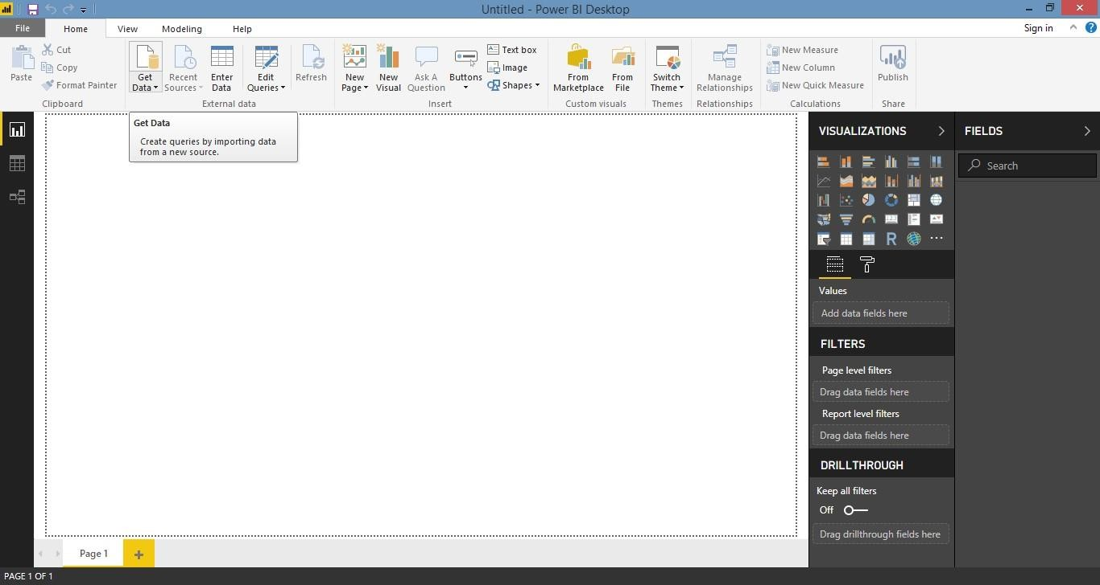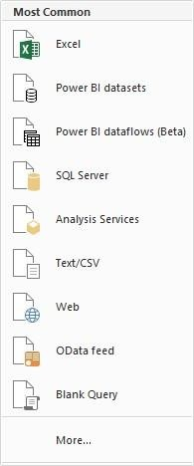

Step 2: Click on Get data following list will be displayed → select Excel

Step 3: Select required file and click on Open, Navigator screen appears

.

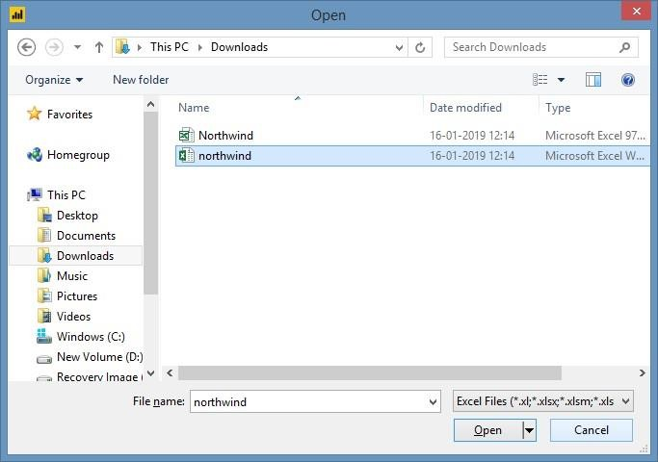

Step 4: Select file and click on edit

Step 5: Power query editor appears

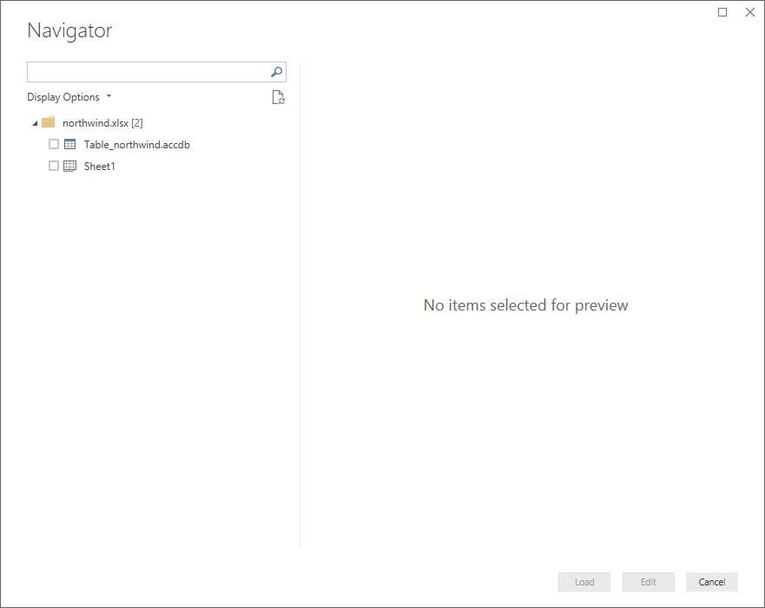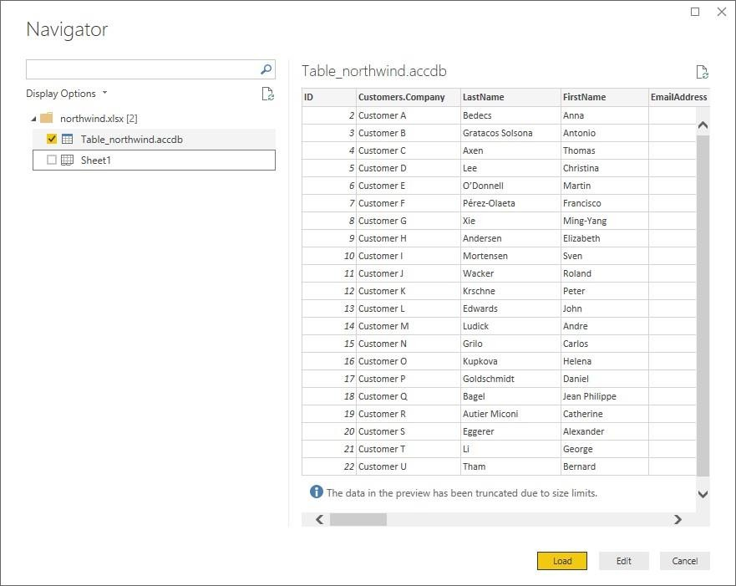

Step 6: Again, go to Get Data and select OData feed

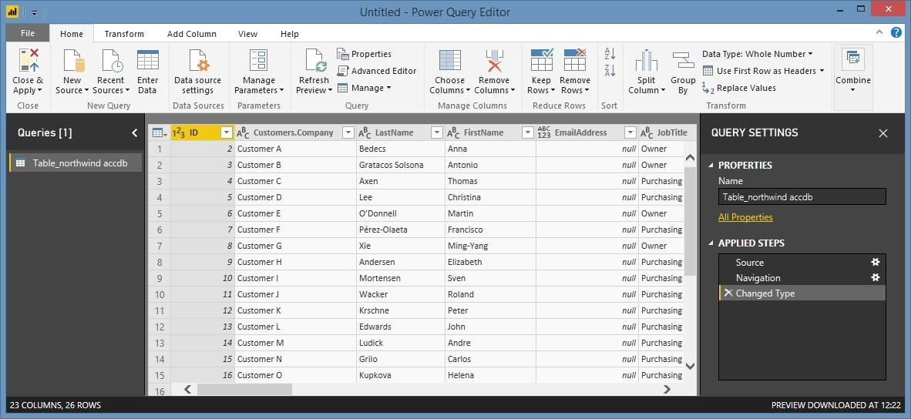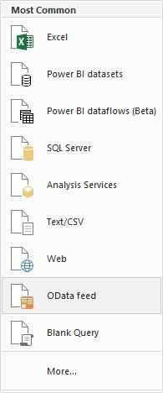

Step 7:

Paste url as <http://services.odata.org/V3/Northwind/Northwind.svc/> Click on ok

Step 8: Select orders table And click on edit

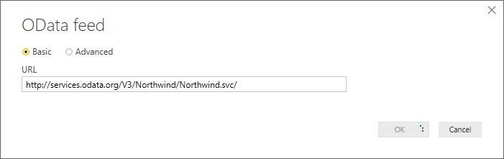

Note: If you just want to see preview you can just click on table name without clicking on checkbox Click on edit to view table

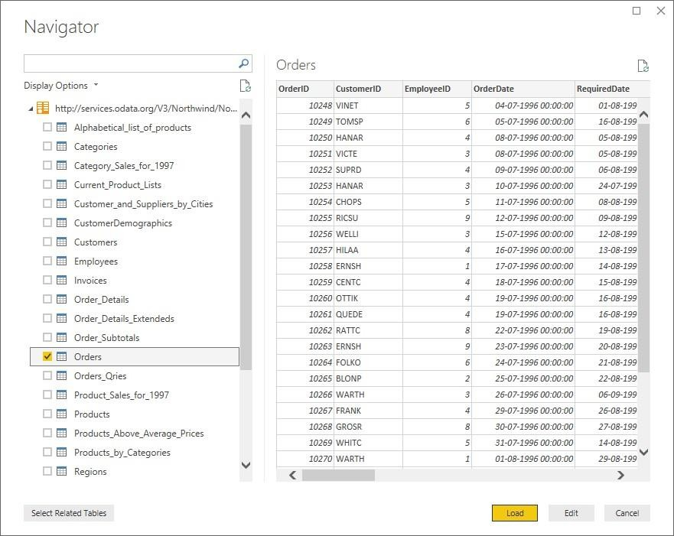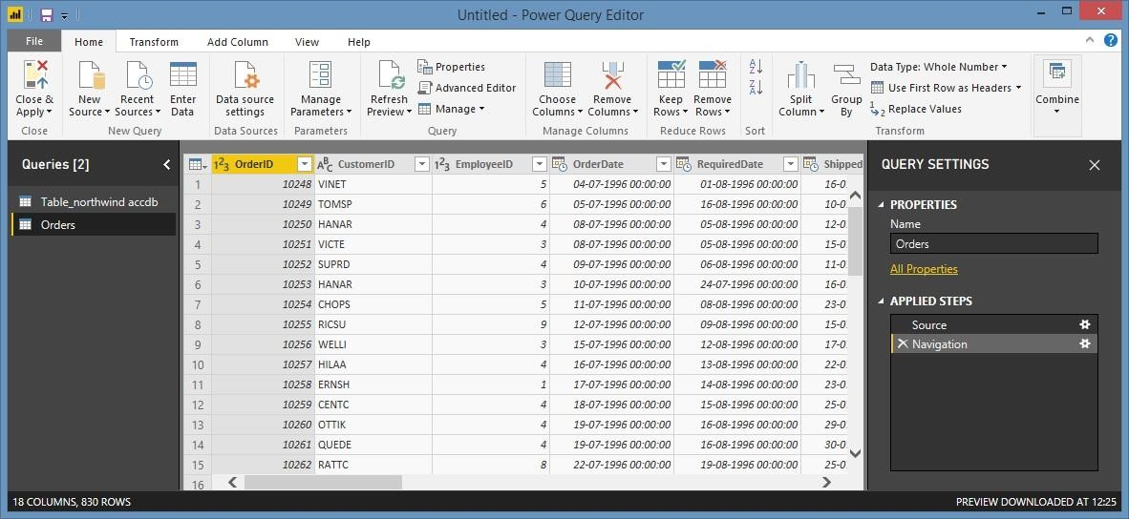

**Learning Outcomes:**

**Course Outcomes:**

**Conclusion:**

**Viva Questions:**

1. **Define data loading.**
2. **What is incremental loading?**
3. **Why validate data during loading?**
4. **Mention one data loading challenge.**

**For Faculty use:**

|  |  |  |  |
| --- | --- | --- | --- |
| Correction Parameters | Formative Assessment[40%] | Timely Completion of Practical[40%] | Attendance Learning Attitude[20%] |
|  |  |  |  |





**SHRI GPM DEGREE COLLEGE OF SCIENCE & COMMERCE**

Department of Computer

**Affiliated to University of Mumbai**

Vision.. Innovation.. Solution.. Presentation..



**Practical-2: Perform the Extraction Transformation and Loading (ETL) -process to construct the database in the Sql server.**



**Aims:**

1. To implement a complete ETL process by extracting data from multiple sources, transforming it as necessary, and loading it into a SQL Server database.
2. To build a reliable and optimized database using ETL techniques for improved data management and

reporting.



**Learning Objectives:**

1. Understand the ETL methodology and its role in data warehousing.
2. Gain proficiency in extracting data from diverse sources such as Excel, SQL Server, and Oracle.
3. Learn to perform data transformations including cleansing, formatting, and aggregation.
4. Master the process of loading transformed data into SQL Server and validating its integrity.



**Tool & Technologies used:**

1. Power BI is a powerful business intelligence tool used for data visualization and analysis.



**Theory-2: Extraction**

Extraction is the first phase of the ETL (Extract, Transform, Load) process, which is essential for

constructing a database in SQL Server. This step involves retrieving data from multiple sources such as

relational databases, flat files, APIs, and cloud storage systems to ensure that accurate and relevant data is available for further processing.



**Process of Extraction**



The extraction process includes the following steps:

1. **Identifying Data Sources:** Determine and analyze the structure and format of legacy data sources.
2. **Data Retrieval:** Extract data using various methods such as SQL queries, API calls, or file parsing.
3. **Data Staging:** Store the extracted data temporarily in a staging area to maintain integrity before transformation.
4. **Data Validation:** Check data completeness, consistency, and correctness to ensure reliability.



**Types of Extraction**

* **Full Extraction:** Extracts all data from the source system at once, typically used for initial loads.
* **Incremental Extraction:** Only new or modified data is extracted periodically, reducing system load.
* **Real-time Extraction:** Continuous extraction to support real-time analytics and processing.





**Challenges and Considerations**

* **Performance Issues:** Large data volumes can impact system performance; optimizing queries and indexing helps mitigate this.
* **Data Integrity:** Ensure extracted data remains consistent and unaltered during transfer.
* **Security Concerns:** Implement encryption and secure connections to protect sensitive data.
* **Handling Data Anomalies:** Implement error detection and correction mechanisms to avoid loading faulty data.

PRACTICAL 2

Perform the Extraction Transformation and Loading (ETL) process to construct the database in the Power BI.

Step 1: Open Power BI, Click on Get Data → OData Feed

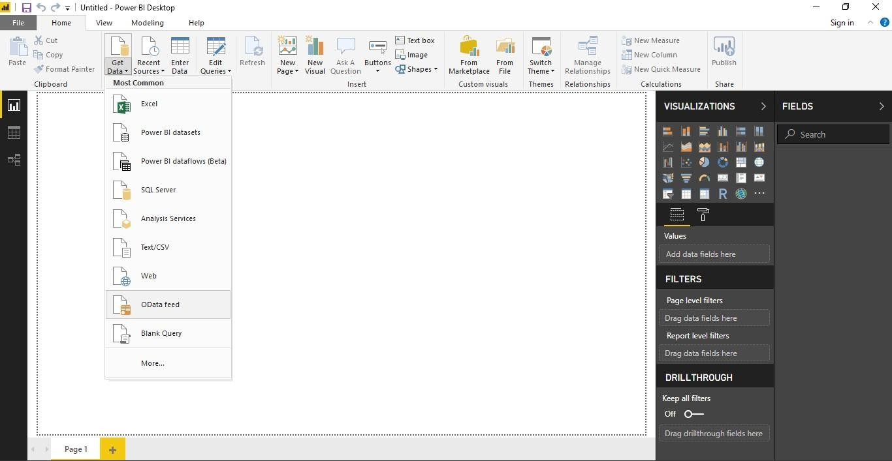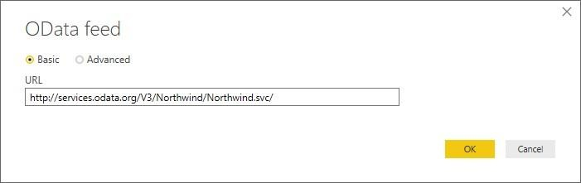

Paste Url : <http://services.odata.org/V3/Northwind/Northwind.svc/> And Click OK

Step 2: Click on Check Box of Products table and then click on Edit

1) Remove other columns to only display columns of interest

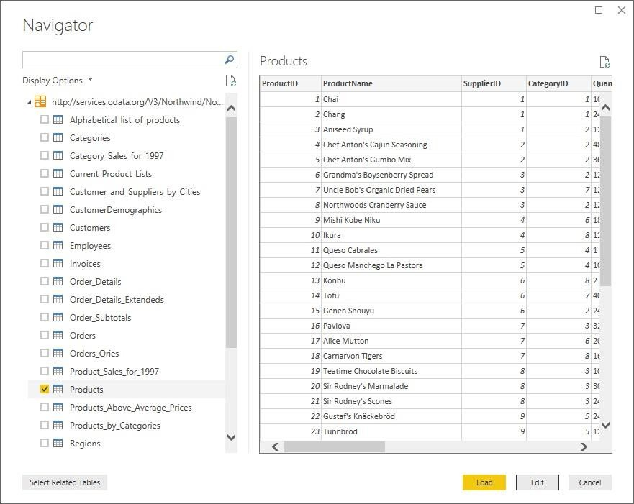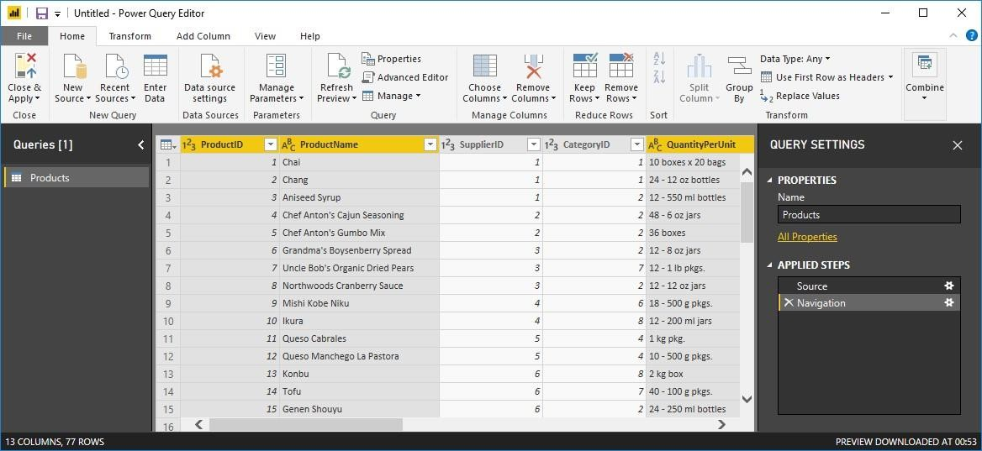

In Query Editor, select the ProductID, ProductName, QuantityPerUnit, and

UnitsInStock columns (use Ctrl+Click to select more than one column, or Shift+Click to select columns that are beside each other).

Select Remove Columns > Remove Other Columns from the ribbon, or rightclick on a column header and click Remove Other Columns

After selecting Remove Other Columns only selected four columns are displayed other columns are discarded.

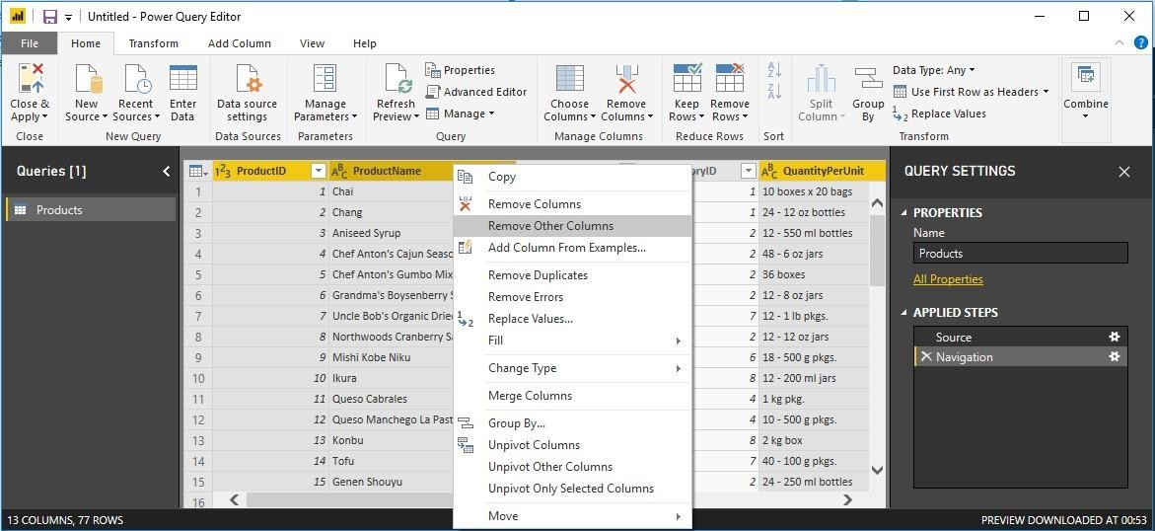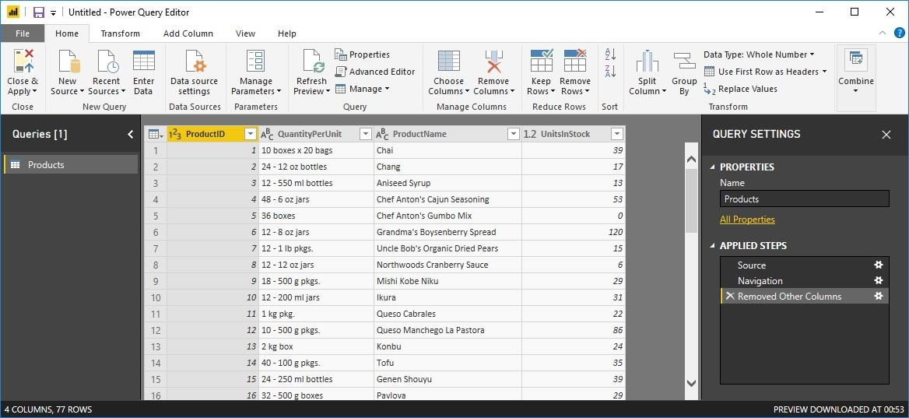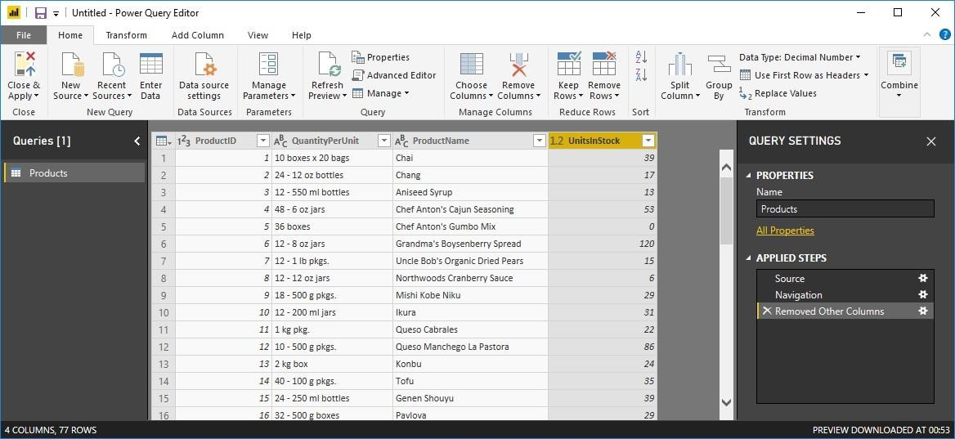

1. Change the data type of the UnitsInStock column
   1. Select the UnitsInStock column.

Check if the data type of selected column is a Whole number

* 1. Select the Data Type drop-down button in the Home ribbon.
  2. If not already a Whole Number, select Whole Number for data type from the drop down (the Data Type: button also displays the data type for the current selection).

After clicking on Whole number, you can see the changed Datatype in column header of UnitsInStock.

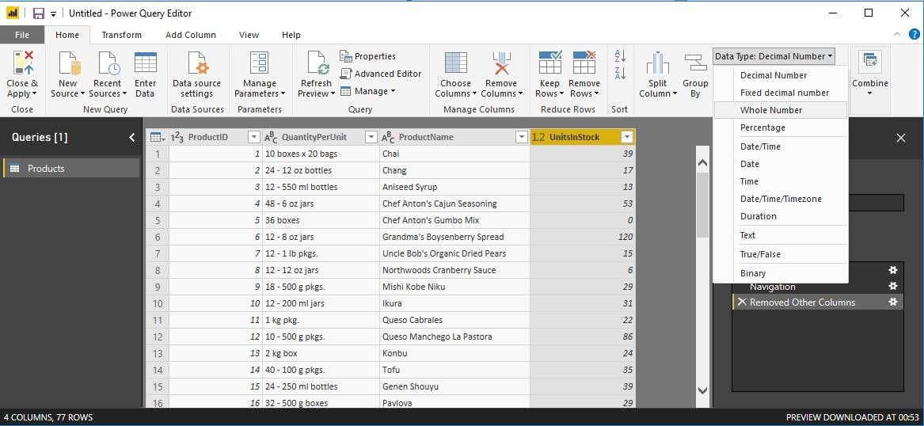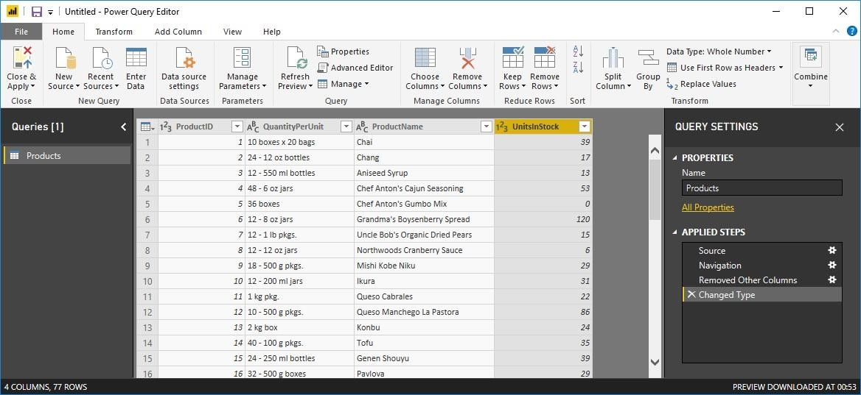

After above step, close query editor and click on Yes to save changes.

Now you can view fields of Products table on right side, check all the fields of table to get representation in charts form.

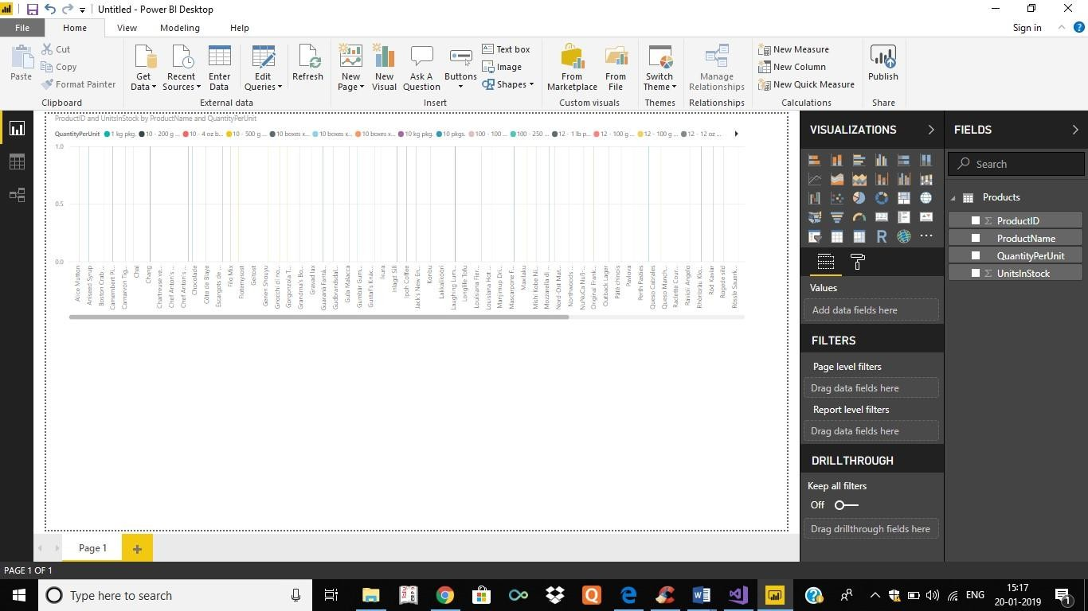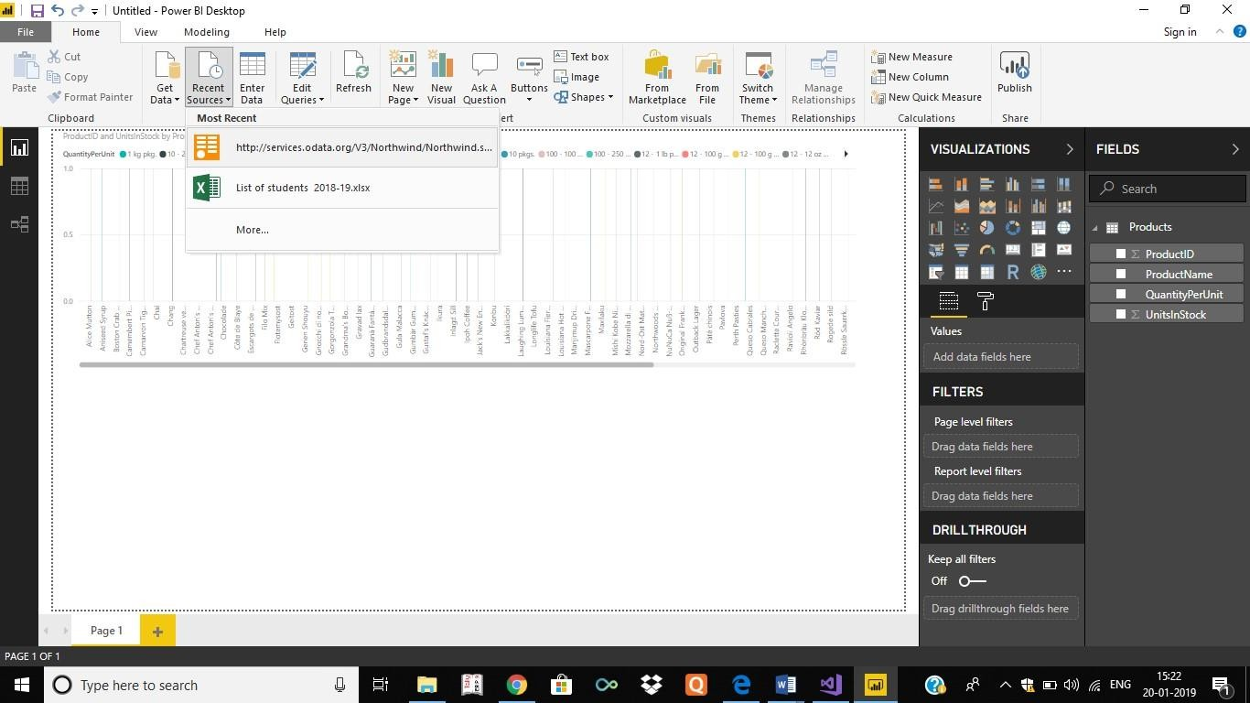

1. Expand the Orders table

Once You have loaded a data source, you can click on Recent Sources to select desired table (Orders).

After selecting the URL, Navigator window will appear from which you can select Orders table. Click on Edit.



Query Editor Window will appear

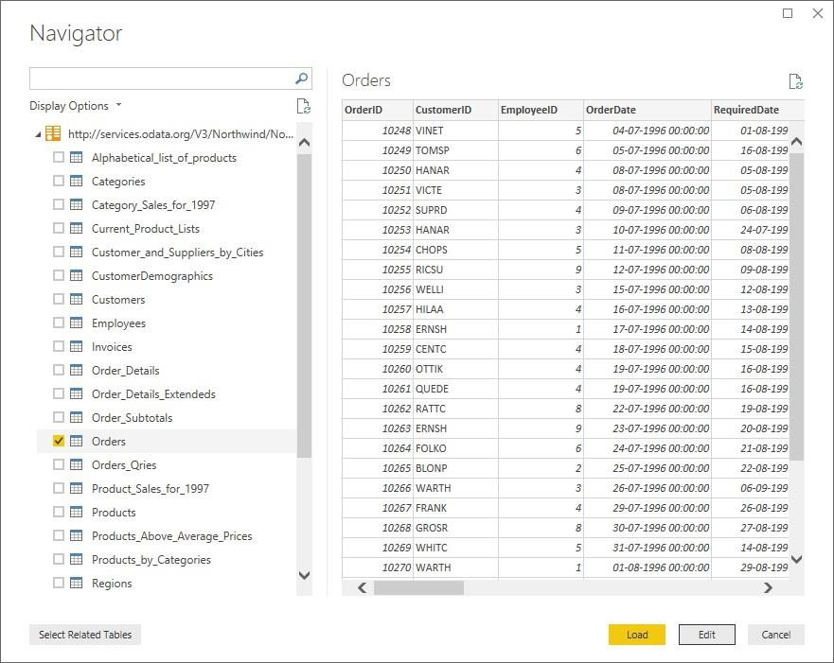

1. In the Query View, scroll to the Order_Details column.
2. In the Order_Details column, select the expand icon .
3. In the Expand drop-down:
   1. Select (Select All Columns) to clear all columns.
   2. Select ProductID, UnitPrice, and Quantity.
   3. Click OK.

After clicking on OK following screen appears with combined columns

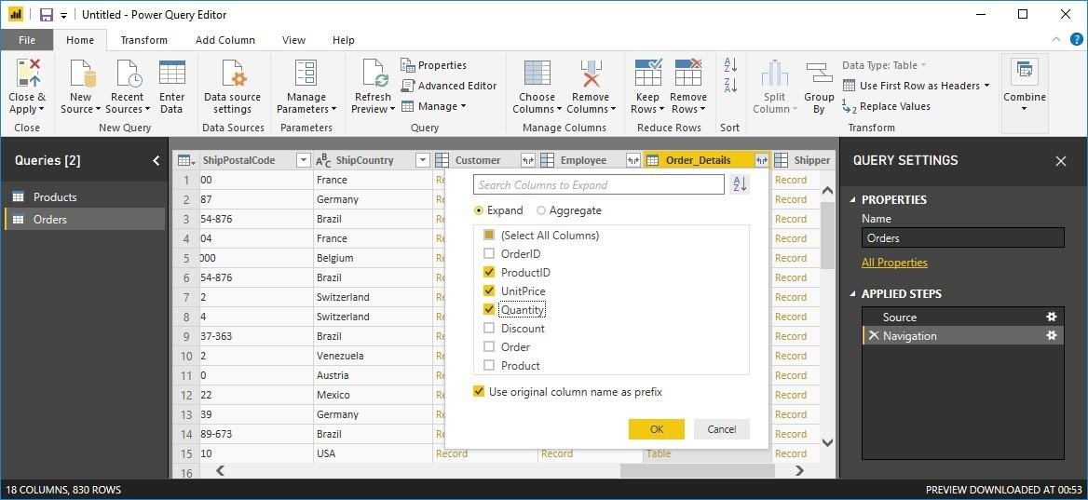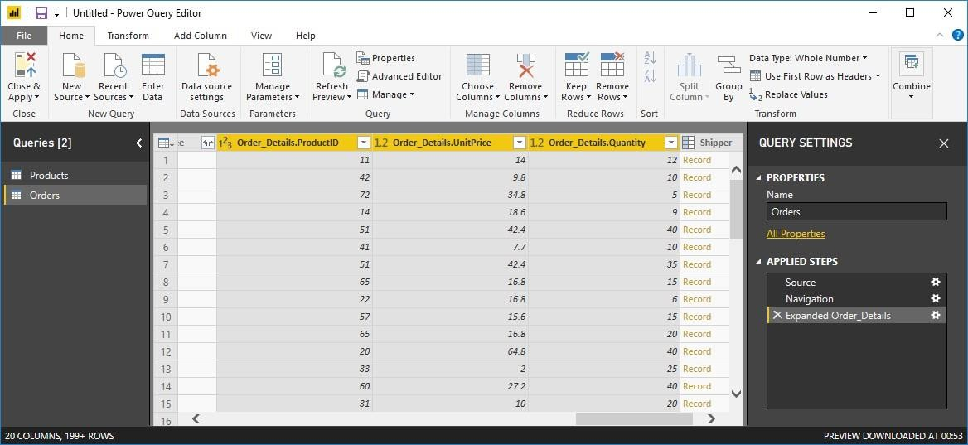

1. Calculate the line total for each Order_Details row

Power BI Desktop lets you to create calculations based on the columns you are importing, so you can enrich the data that you connect to. In this step, you create a Custom Column to calculate the line total for each Order_Details row.

Calculate the line total for each Order_Details row:

1. In the Add Column ribbon tab, click Add Custom Column.
2. In the Custom Column dialog box, in the Custom Column Formula textbox, enter [Order_Details.UnitPrice] *

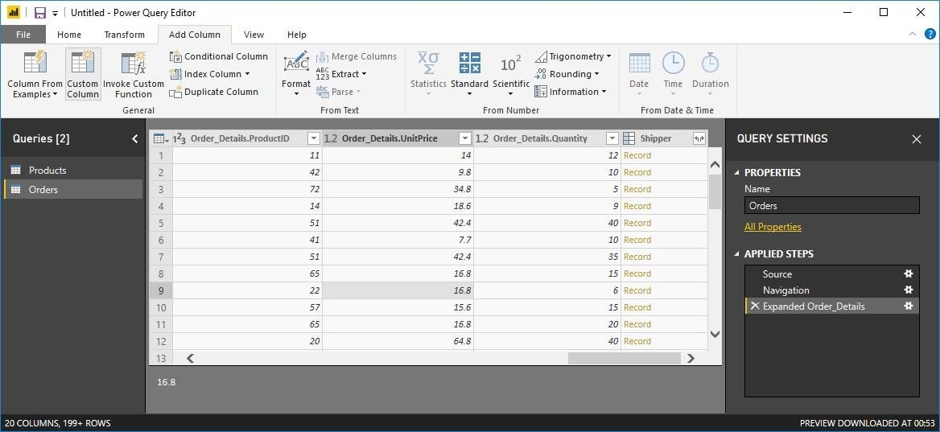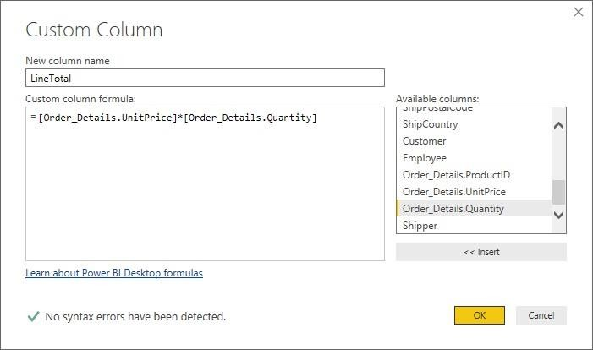

[Order_Details.Quantity] by selecting from available columns and click on insert for each column.

1. In the New column name textbox, enter LineTotal.
2. Click OK.
3. Rename and reorder columns in the query

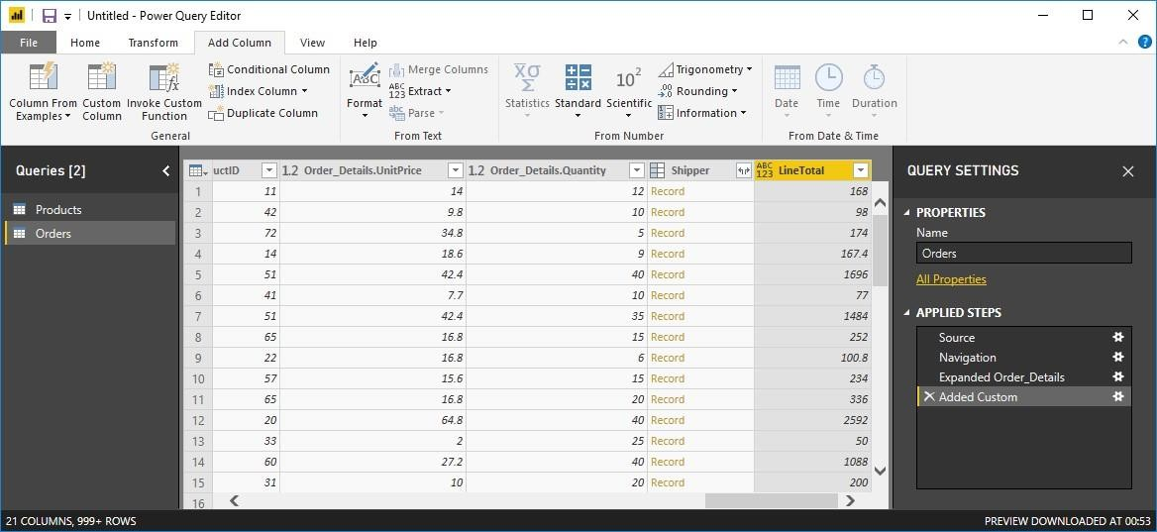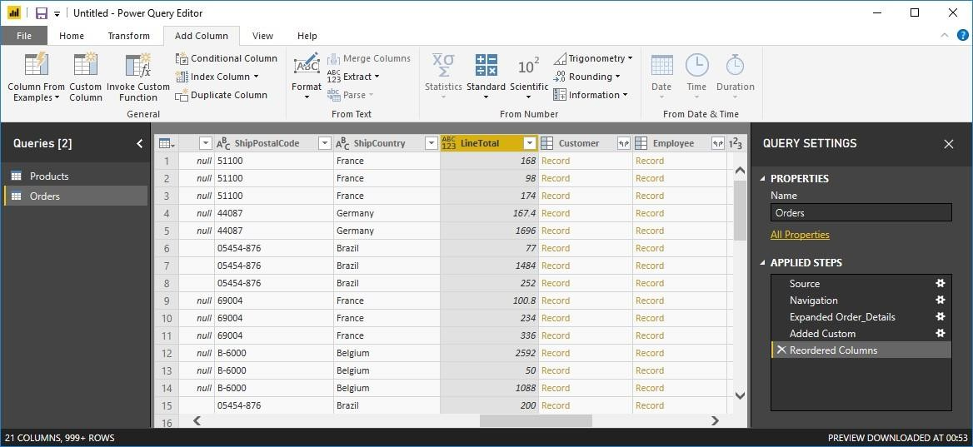

In this step you finish making the model easy to work with when creating reports, by renaming the final columns and changing their order.

1. In Query Editor, drag the LineTotal column to the left, after ShipCountry.
2. Remove the Order_Details. prefix from the Order_Details.ProductID, Order_Details.UnitPrice and Order_Details.Quantity columns, by double-clicking on each column header, and then deleting that text from the column name.

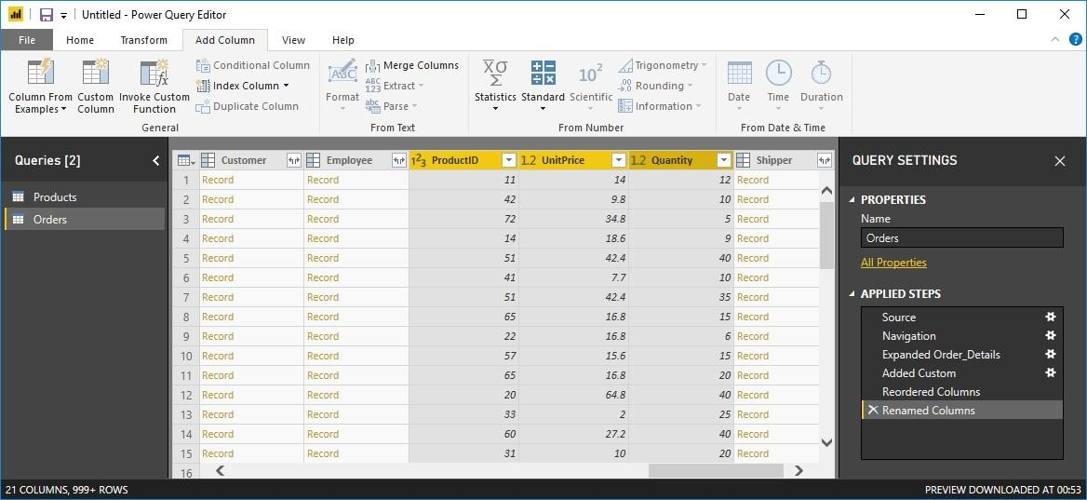

**6.** Combine the Products and Total Sales queries

Power BI Desktop does not require you to combine queries to report on them. Instead, you can create relationships between datasets. These relationships can be created on any column that is common to your datasets.

We have Orders and Products data that share a common 'ProductID' field, so we need to ensure there's a relationship between them in the model we're using with Power BI Desktop. Simply specify in Power BI Desktop that the columns from each table are related (i.e. columns that have the same values). Power BI Desktop works out the direction and cardinality of the relationship for you. In some cases, it will even detect the relationships automatically.

In this task, you confirm that a relationship is established in Power BI Desktop between the Products and Total Sales queries

Step 1: Confirm the relationship between Products and Total Sales 1. First, we need to load the model that we created in Query Editor into Power BI Desktop. From the Home ribbon of Query Editor, select Close & Apply.

Step 2: Power BI Desktop loads the data from the two queries.

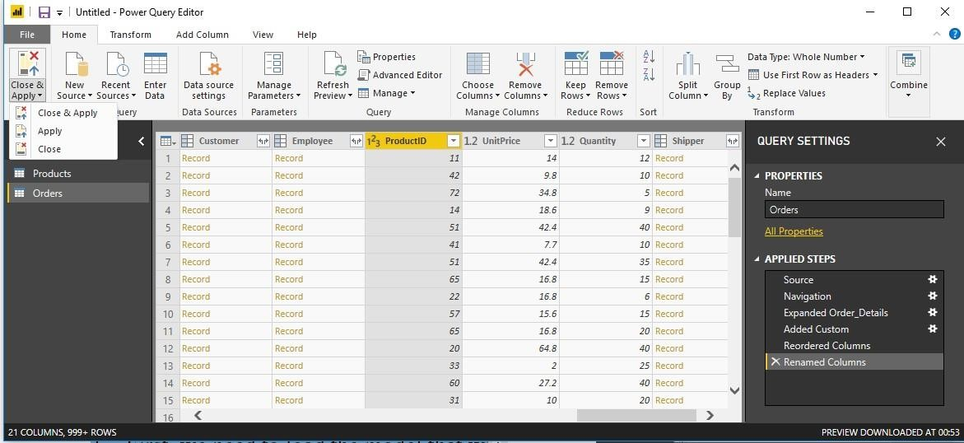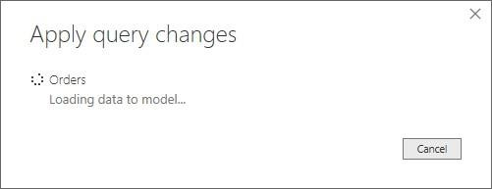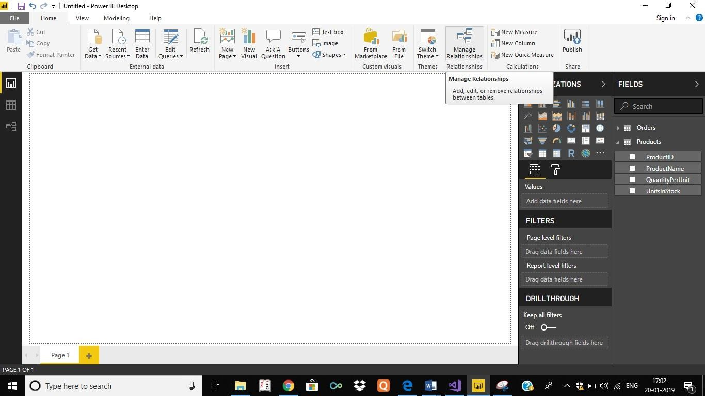

Step 3: Once the data is loaded, select the Manage Relationships button Home ribbon

Step 4. Select the New… button

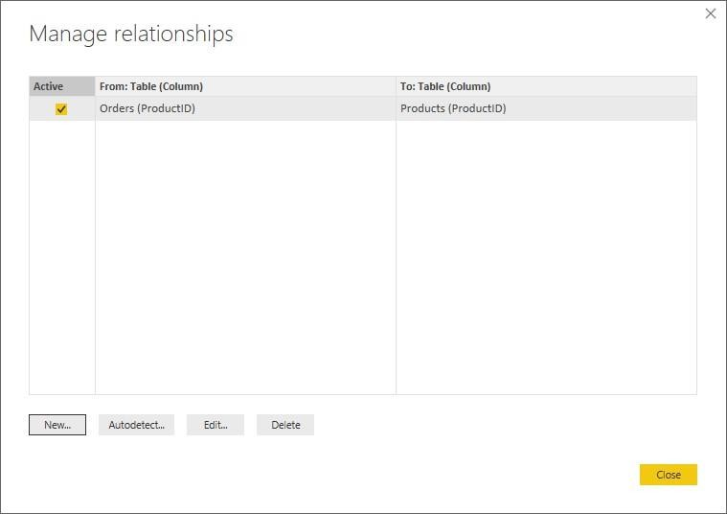

Step 5: When we attempt to create the relationship, we see that one already exists! As shown in the Create Relationship dialog (by the shaded columns), the ProductsID fields in each query already have an established relationship.

Step 6: Select Cancel, and then select Relationship view in Power BI Desktop.

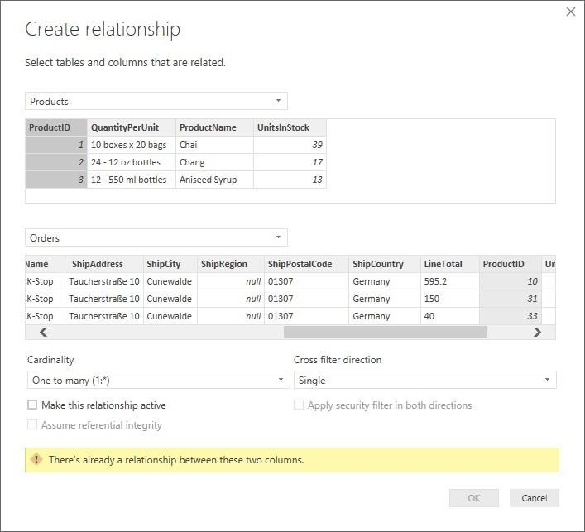

Step 7: We see the following, which visualizes the relationship between the queries.

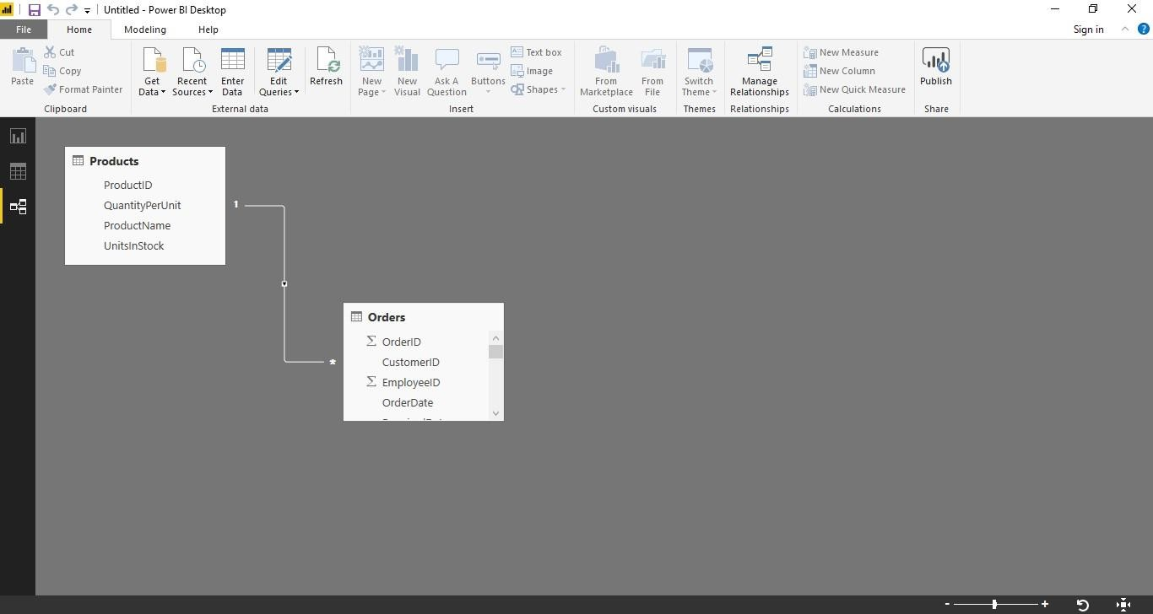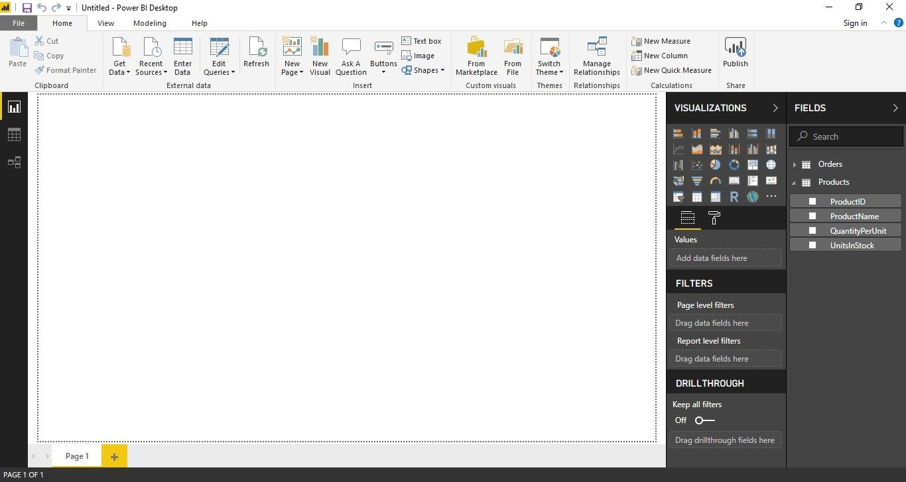

Step 8: When you double-click the arrow on the line that connects the to queries, an Edit Relationship dialog appears.

Step 9: No need to make any changes, so we'll just select Cancel to close the Edit Relationship dialog.

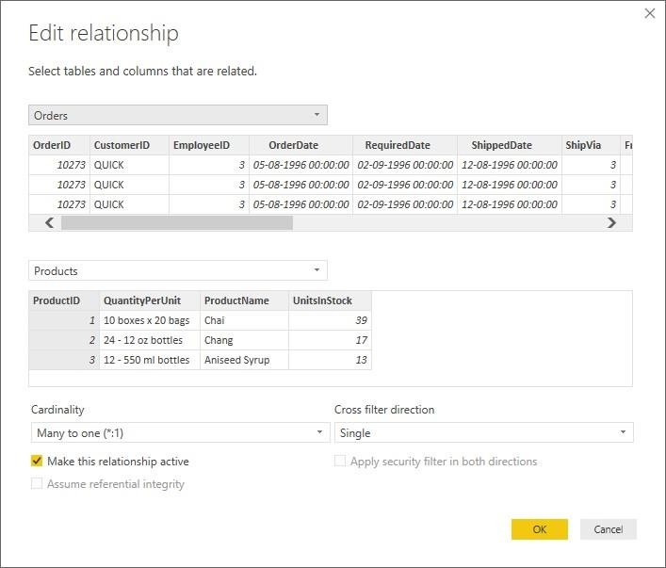

**Learning Outcomes:**

**Course Outcomes:**

**Conclusion:**

**Viva Questions:**

* 1. **What is extraction?**
  2. **Name an extraction tool.**
  3. **What is incremental extraction?**
  4. **Why is extraction important?**

**For Faculty use:**

|  |  |  |  |
| --- | --- | --- | --- |
| Correction Parameters | Formative Assessment[40%] | Timely Completion of Practical[40%] | Attendance Learning Attitude[20%] |
|  |  |  |  |



**SHRI GPM DEGREE COLLEGE OF SCIENCE & COMMERCE**

Department of Computer

**Affiliated to University of Mumbai**

Vision.. Innovation.. Solution.. Presentation..



**Practical-3: a. Create the Data staging area for the selected database.**

**b. Create the cube with suitable dimension and fact tables based on ROLAP, MOLAP and HOLAP model.**



**Aims:**

1. To create a dedicated data staging area for the selected database, enabling efficient data cleansing, transformation, and preparation for analysis.
2. To design and construct a multidimensional cube with appropriate dimension and fact tables using ROLAP, MOLAP, and HOLAP models for enhanced data analysis.



**Learning Objectives:**

1. Understand the role of data staging in the ETL and data warehousing process.
2. Gain hands-on experience in setting up a staging area to extract, clean, and transform raw data.
3. Learn the fundamentals of cube design, including the creation of dimension and fact tables.
4. Explore the differences and use cases for ROLAP, MOLAP, and HOLAP models in multidimensional analysis.



**Tool & Technologies used:**

1. Power BI is a powerful business intelligence tool used for data visualization and analysis.



**Theory-3: Data staging**

Data staging is a crucial phase in data warehousing where extracted data is temporarily stored, cleansed, and transformed before being loaded into the target database. This ensures data quality, integrity, and optimized performance for analytical processing.

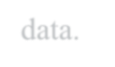

**Creating a Data Staging Area**

1. **Database Selection:** Choose a suitable database system (e.g., SQL Server, Oracle) to store the staged data.
2. **Schema Design:** Define staging tables to hold raw, intermediate, and transformed data.
3. **Data Loading:** Extracted data from multiple sources is loaded into the staging area for preprocessing.
4. **Data Cleansing:** Perform data validation, deduplication, and format standardization.
5. **Transformation:** Apply necessary business rules, data aggregation, and normalization before transferring data to the data warehouse.



**Creating a Cube with Suitable Dimensions and Fact Tables**





1. **Choosing the OLAP Model:**
   * **ROLAP (Relational OLAP):** Stores data in relational databases and processes queries dynamically.
   * **MOLAP (Multidimensional OLAP):** Stores pre-aggregated data in multidimensional cubes for faster access.
2. **Defining Fact Tables:**
   * Contains measurable business data (e.g., sales, revenue, transaction count).
   * Linked with dimension tables using foreign keys.
3. **Defining Dimension Tables:**
   * Stores descriptive attributes (e.g., time, product, customer, location).
   * Supports data slicing, dicing, and drill-down operations.
4. **Building the Cube:**
   * Organize fact and dimension tables within the chosen OLAP model.
   * Precompute aggregations to enhance query performance.

PRACTICAL 3 b

Create the cube with suitable dimension and fact tables based on OLAP

Step 1: Creating Data Warehouse



Let us execute our T-SQL Script to create data warehouse with fact tables, dimensions and populate them with appropriate test values.

Download T-SQL script attached with this article for creation of Sales Data Warehouse or download from this article “Create First Data Warehouse” and run it in your SQL Server.

Downloading "Data_WareHouse SQLScript.zip" from the article [https://www.codeproject.com/Articles/652108/Create-First-Data-WareHou](https://www.codeproject.com/Articles/652108/Create-First-Data-WareHouse) [se](https://www.codeproject.com/Articles/652108/Create-First-Data-WareHouse)

After downloading extract file in folder.

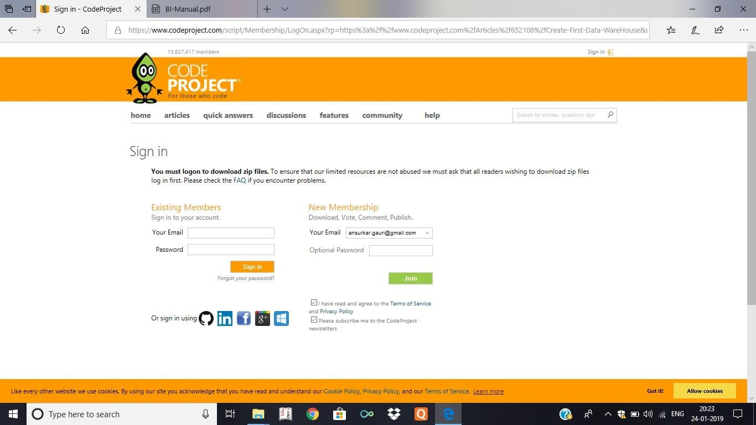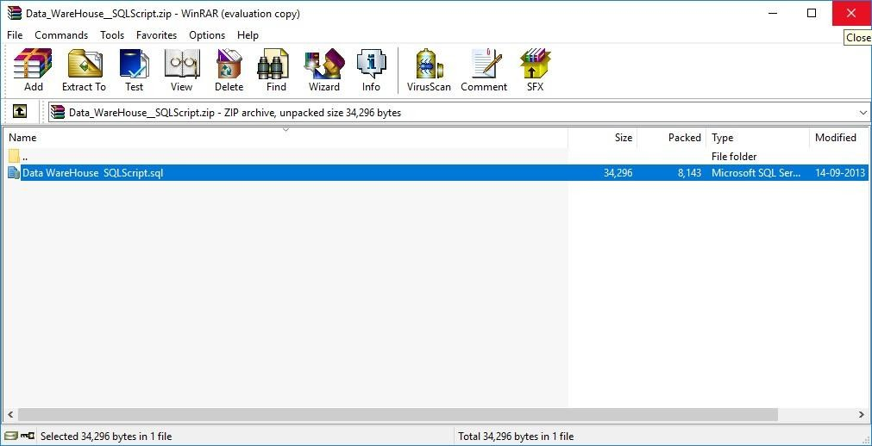

Follow the given steps to run the query in SSMS (SQL Server Management Studio).

1. Open SQL Server Management Studio 2012
2. Connect Database Engine

Password for sa : admin123 (as given during installation) Click Connect.

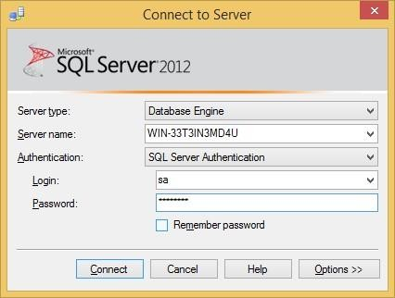

1. Open New Query editor
2. Copy paste Scripts given below in various steps in new query editor window one by one
3. To run the given SQL Script, press F5
4. It will create and populate “Sales_DW” database on your SQL Server

OR

* 1. Go to the extracted sql file and double click on it.
  2. New Sql Query Editor will be opened containing Sales_DW Database.

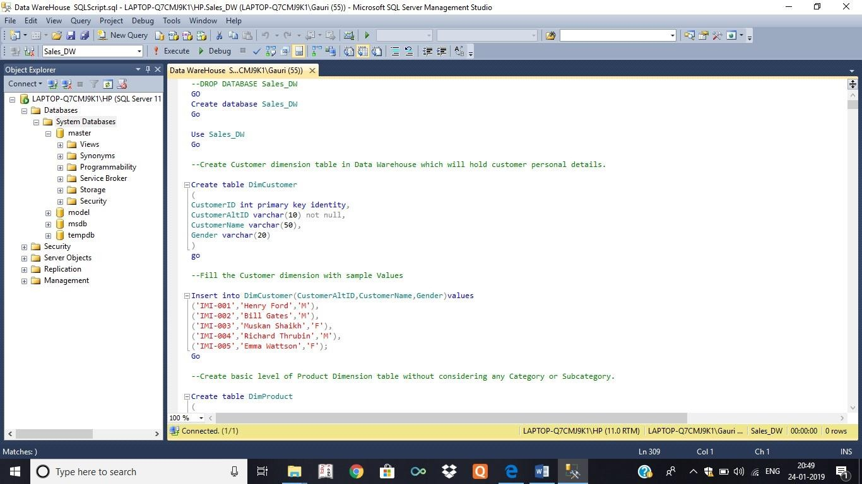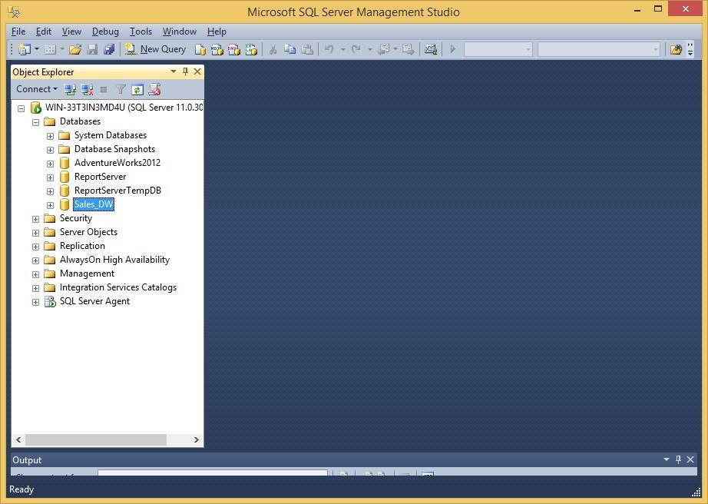

* 1. Click on execute or press F5 by selecting query one by one or directly click on Execute.
  2. After completing execution save and close SQL Server Management studio & Reopen to see Sales_DW in Databases Tab.

Step 2: Start SSDT environment and create New Data Source

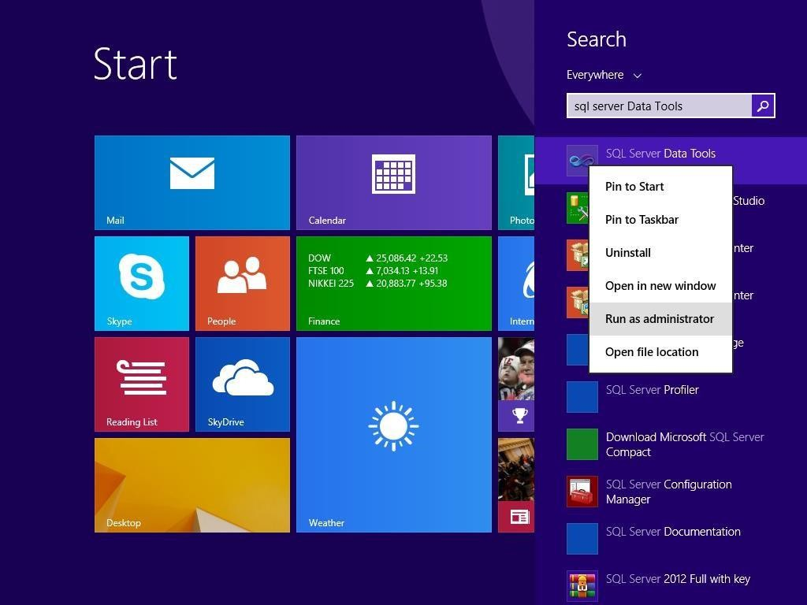

Go to Sql Server Data Tools --> Right click and run as administrator

Click on File → New → Project

In Business Intelligence → Analysis Services Multidimensional and Data Mining models → appropriate project name → click OK

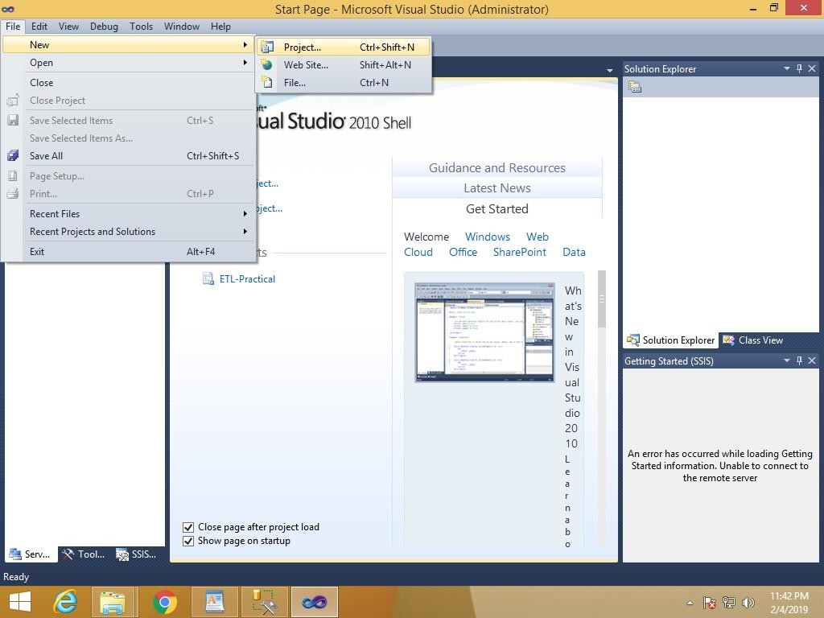

Right click on Data Sources in solution explorer → New Data Source

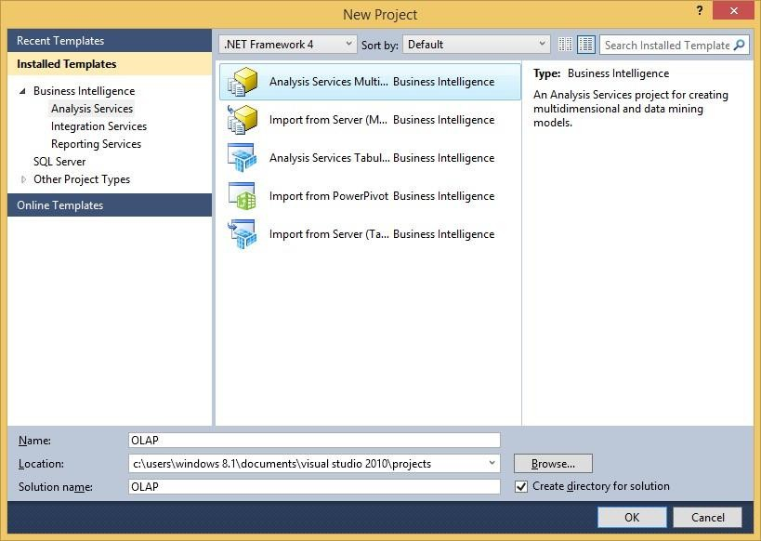

Data Source Wizard appears

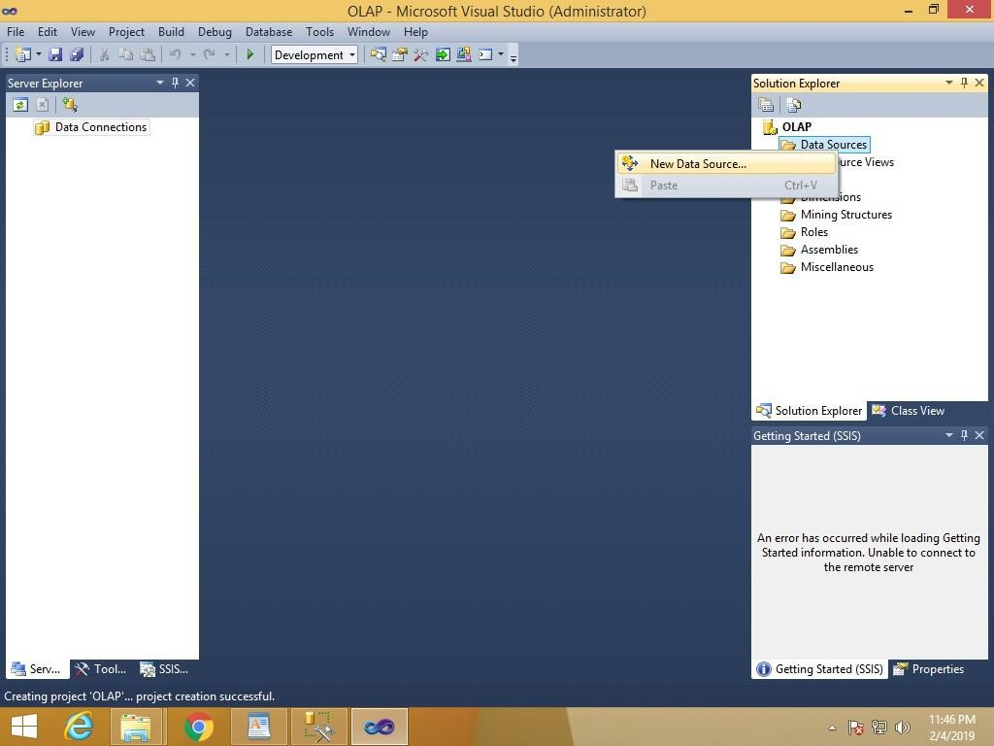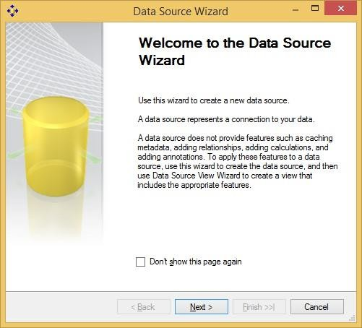

Click on New

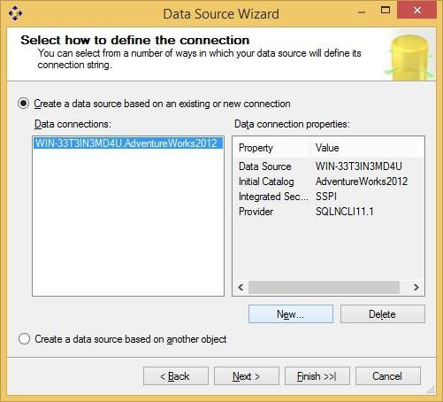

Select Server Name → select Use SQL Server Authentication → Select or enter a database name (Sales_DW)

Note : Password for sa : admin123 (as given during installation of SQL 2012 full version)

Click Next

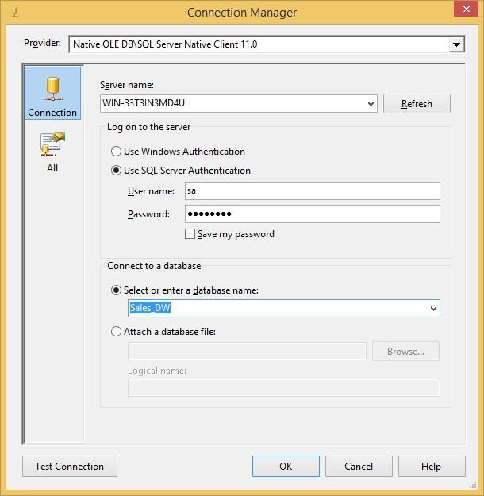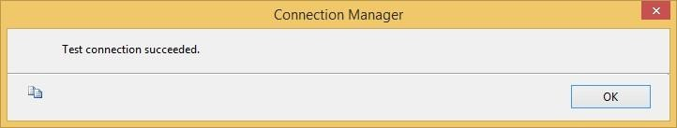

Select Inherit → Next

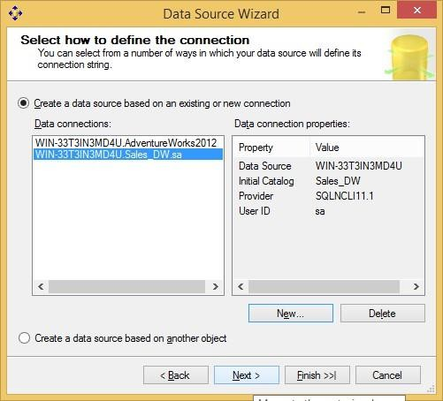

Click Finish

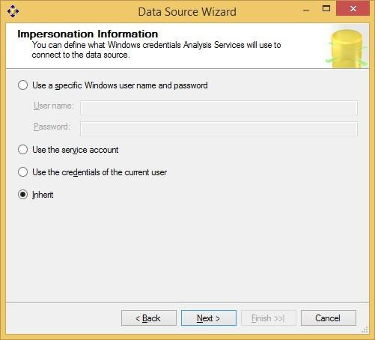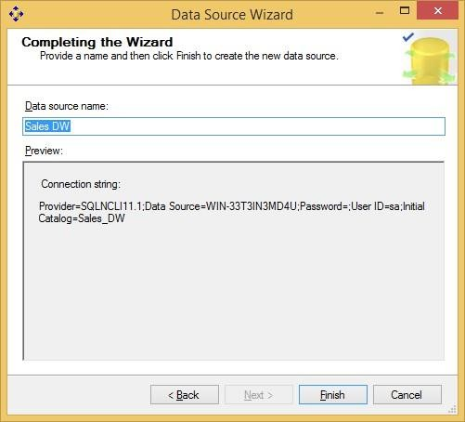

Sales_DW.ds gets created under Data Sources in Solution Explorer

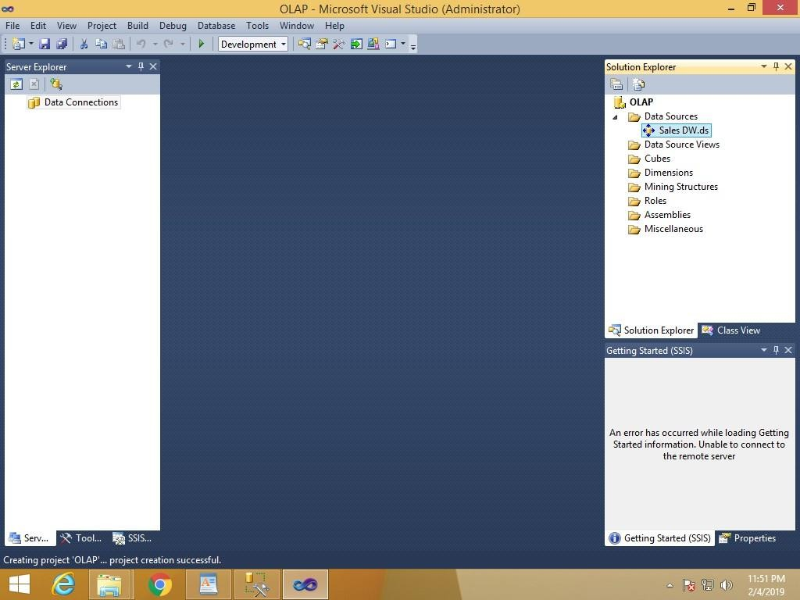

Step 3: Creating New Data Source View

In Solution explorer right click on Data Source View → Select New Data Source View

Click Next

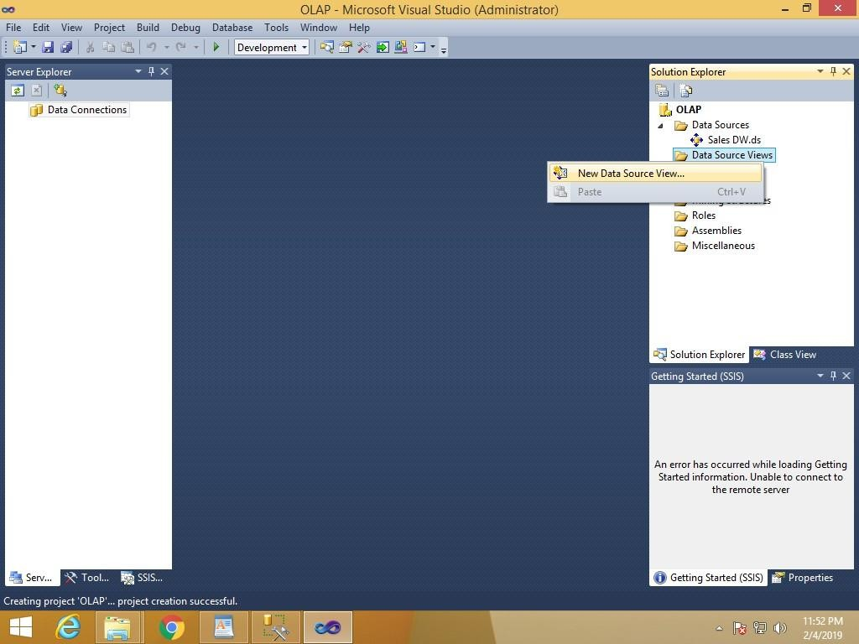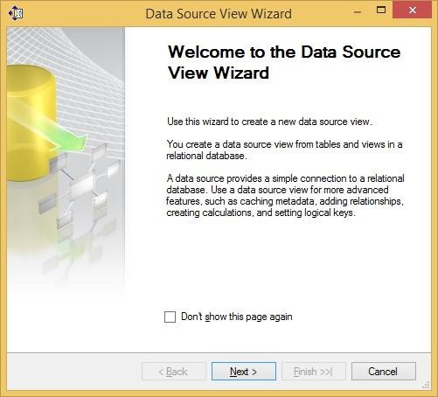

Click Next

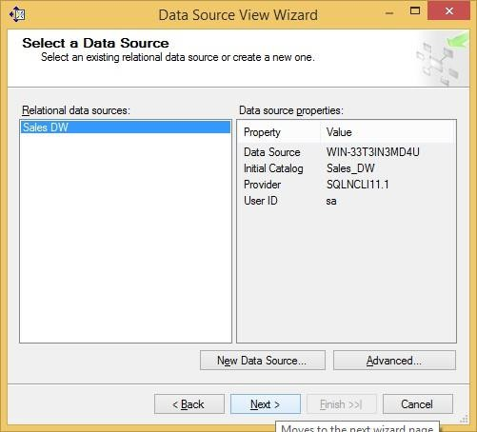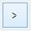

Select FactProductSales(dbo) from Available objects and put in Includes Objects by clicking on

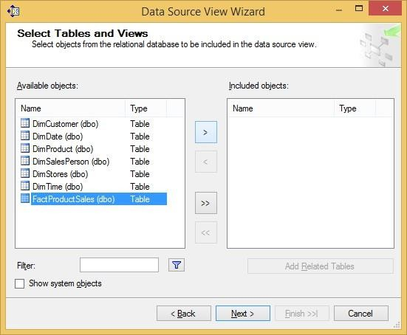

Click on Add Related Tables

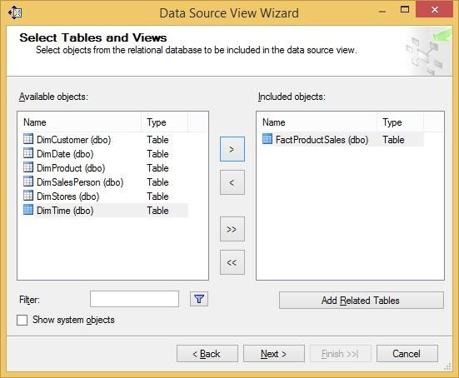

Click Next

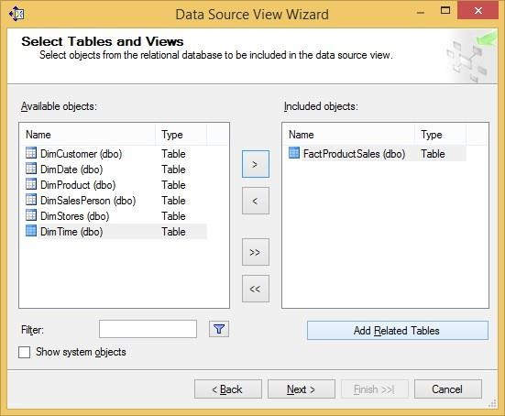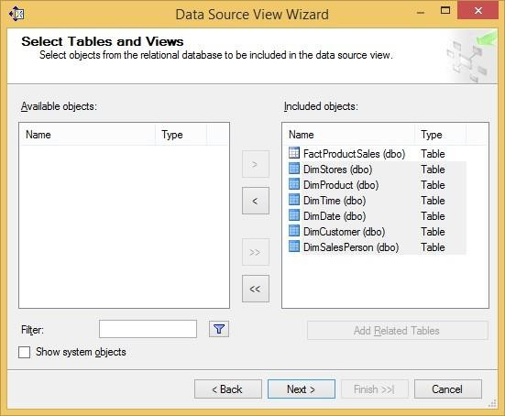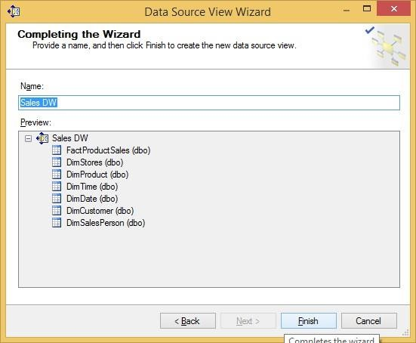

Click Finish

Sales DW.dsv appears in Data Source Views in Solution Explorer.

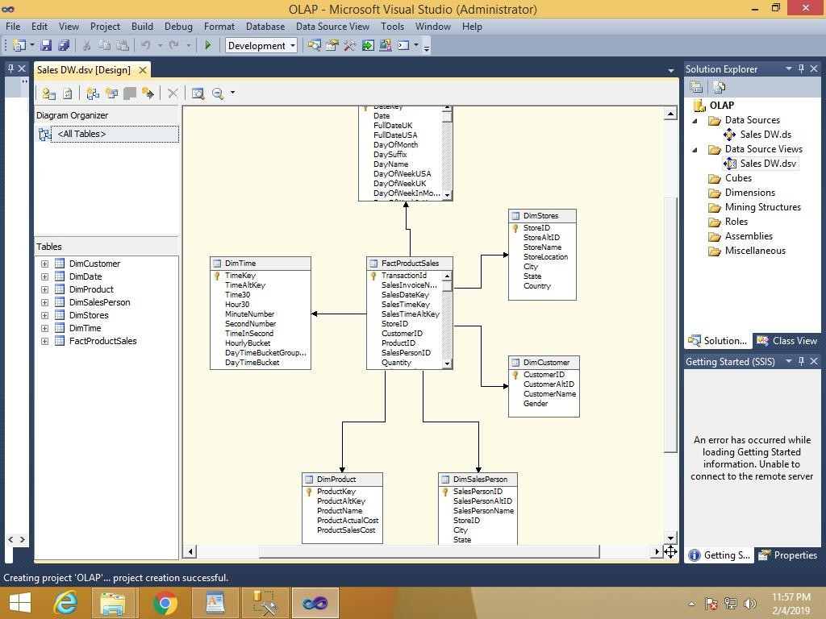

Step 4: Creating new cube

Right click on Cubes → New Cube

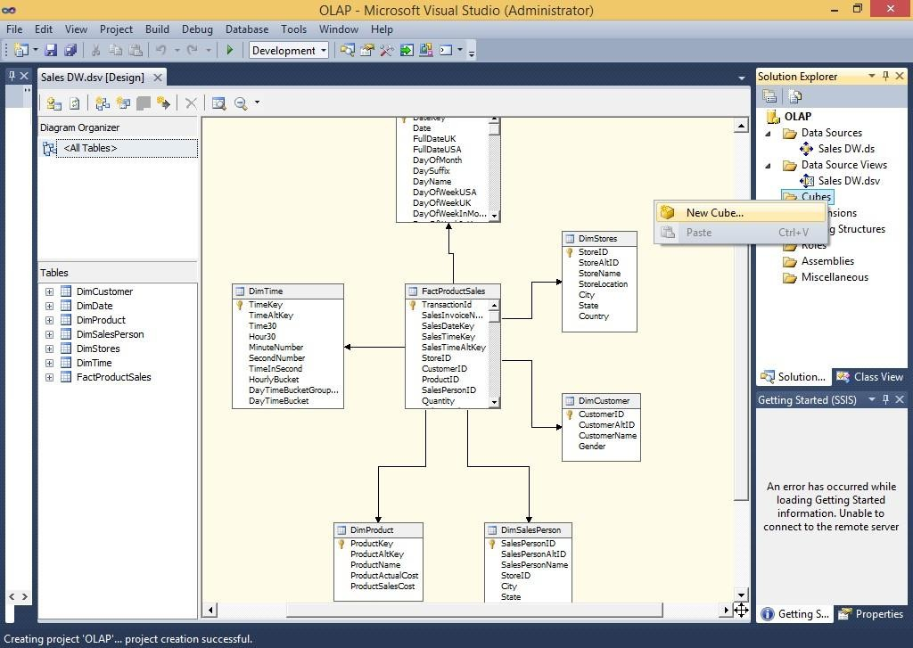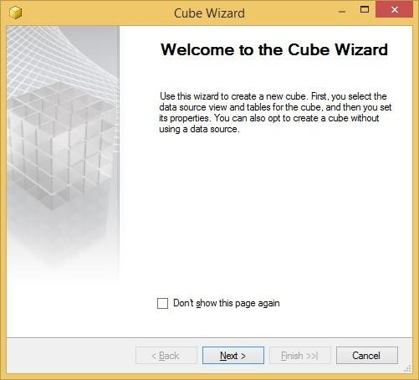

Select Use existing tables in Select Creation Method → Next

In Select Measure Group Tables → Select FactProductSales → Click Next

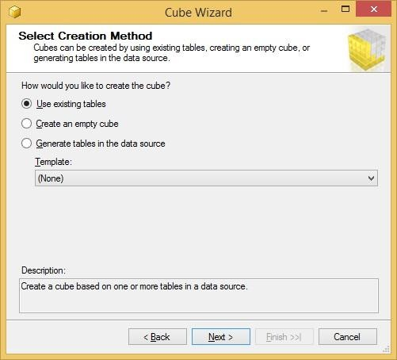

In Select Measures → check all measures → Next

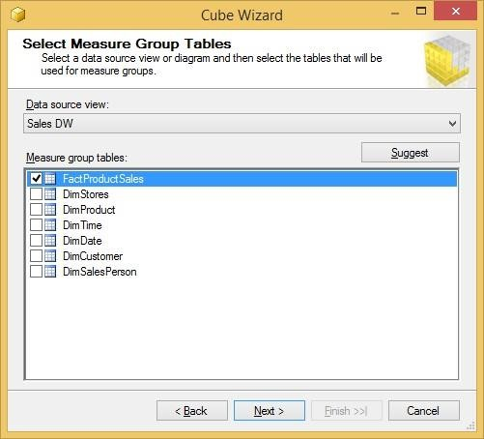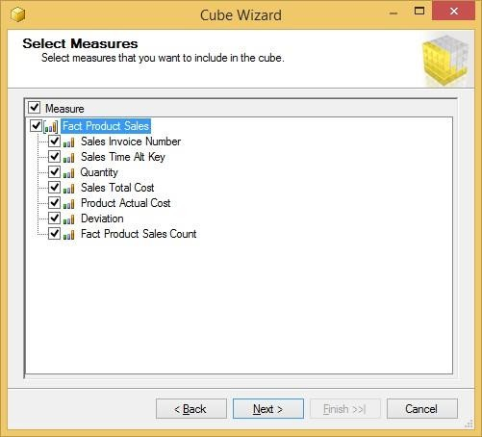

In Select New Dimensions → Check all Dimensions → Next

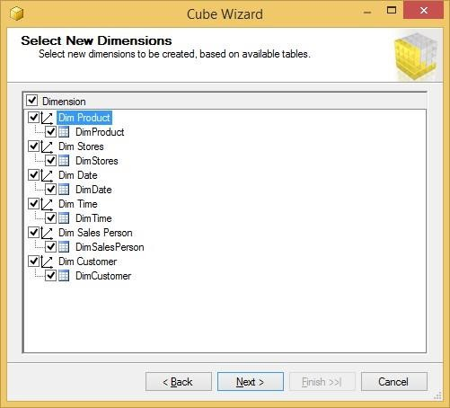

Click on Finish

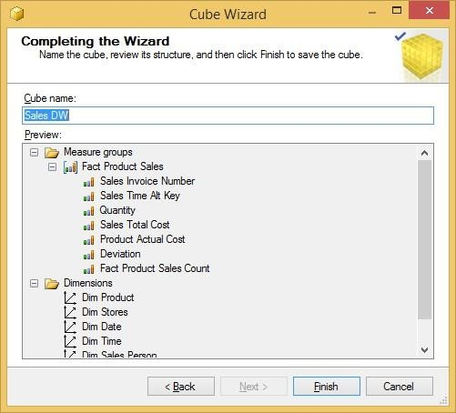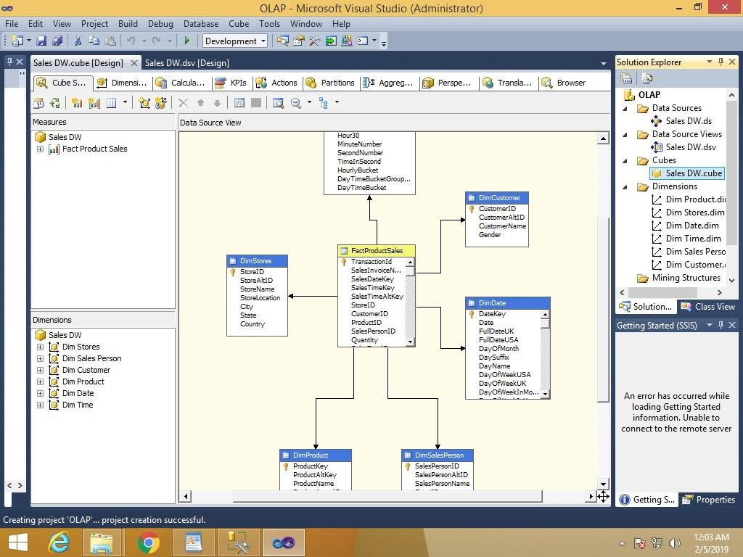

Sales_DW.cube is created

Step 5: Dimension Modification

In dimension tab → Double Click Dim Product.dim

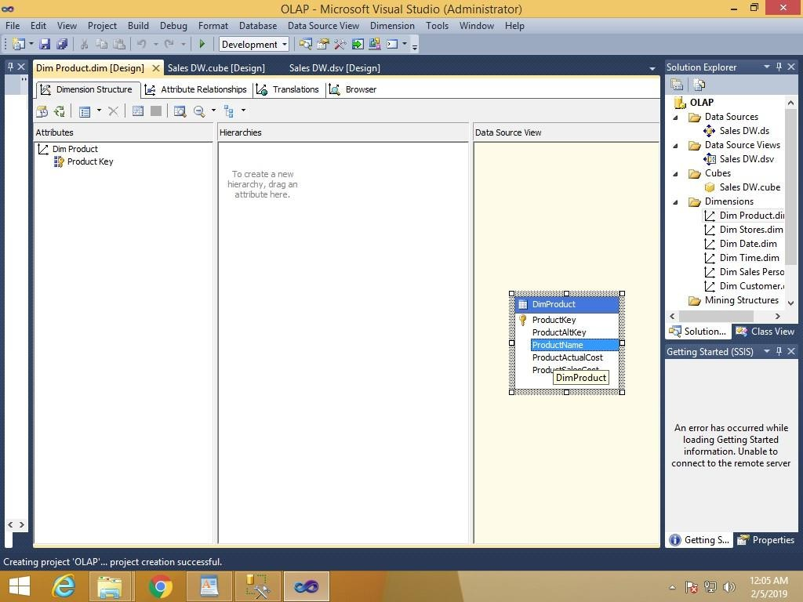

Drag and Drop Product Name from Table in Data Source View and Add in Attribute Pane at left side

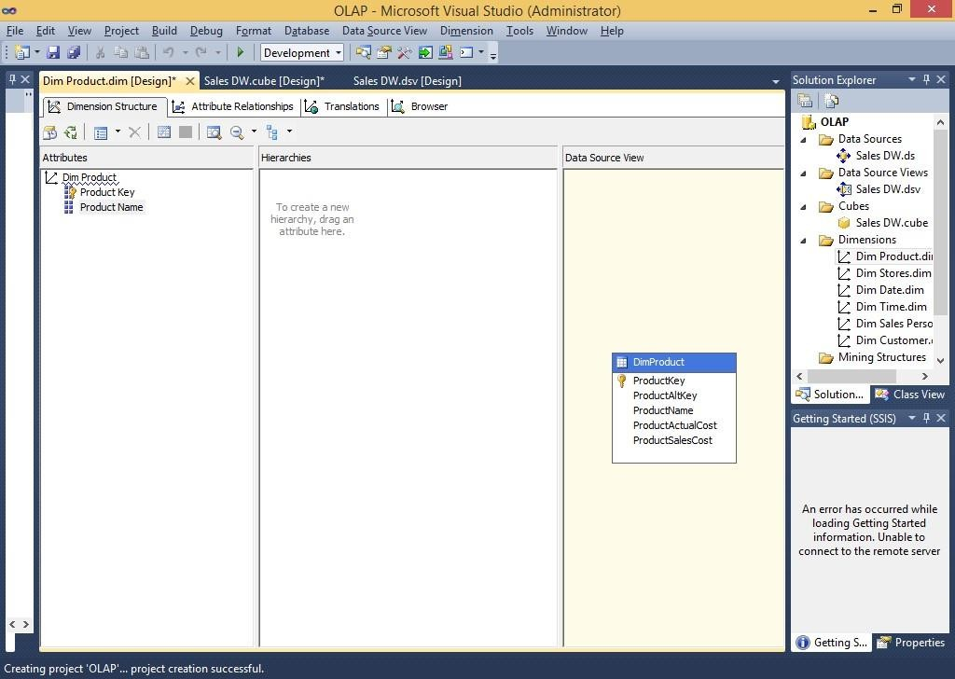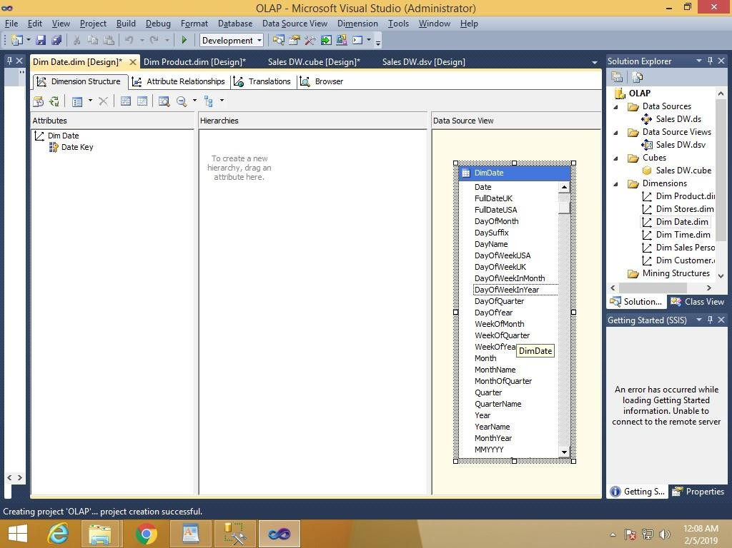

Step 6: Creating Attribute Hierarchy in Date Dimension

Double click On Dim Date dimension -> Drag and Drop Fields from Table shown in Data Source View to Attributes-> Drag and Drop attributes from leftmost pane of attributes to middle pane of Hierarchy.

Drag fields in sequence from Attributes to Hierarchy window (Year, Quarter Name, Month Name, Week of the Month, Full Date UK)

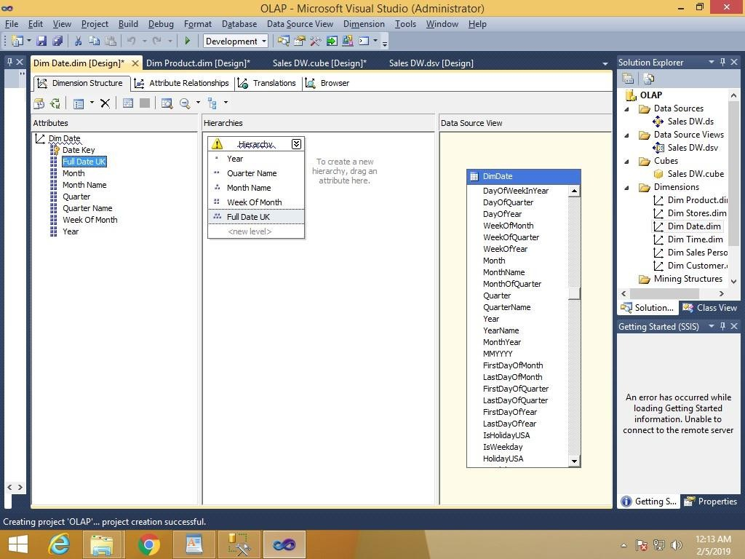

Step 7: Deploy Cube

Right click on Project name → Properties

This window appaers

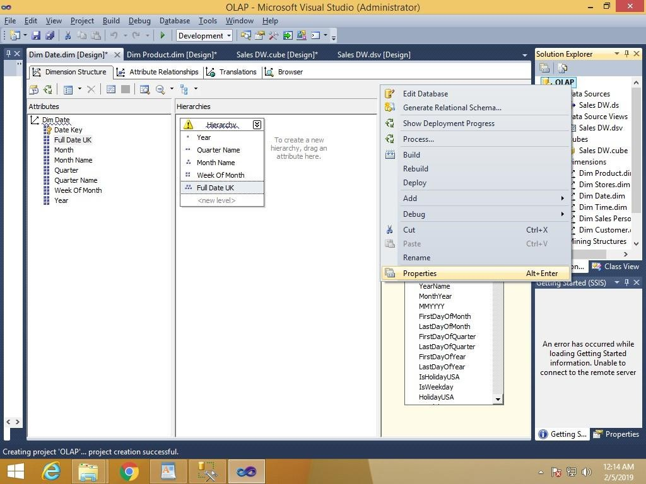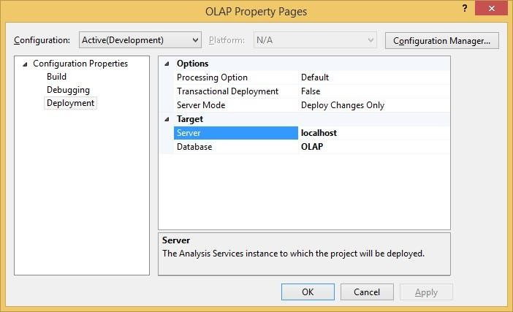

Do following changes and click on Apply & ok

Right click on project name → Deploy

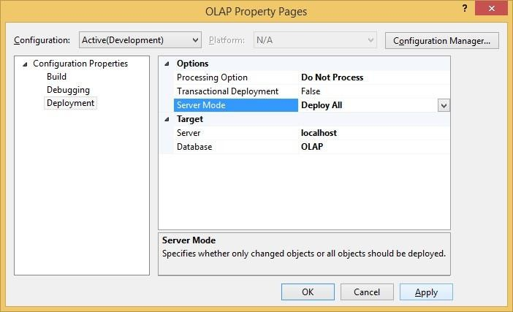

Deployment successful

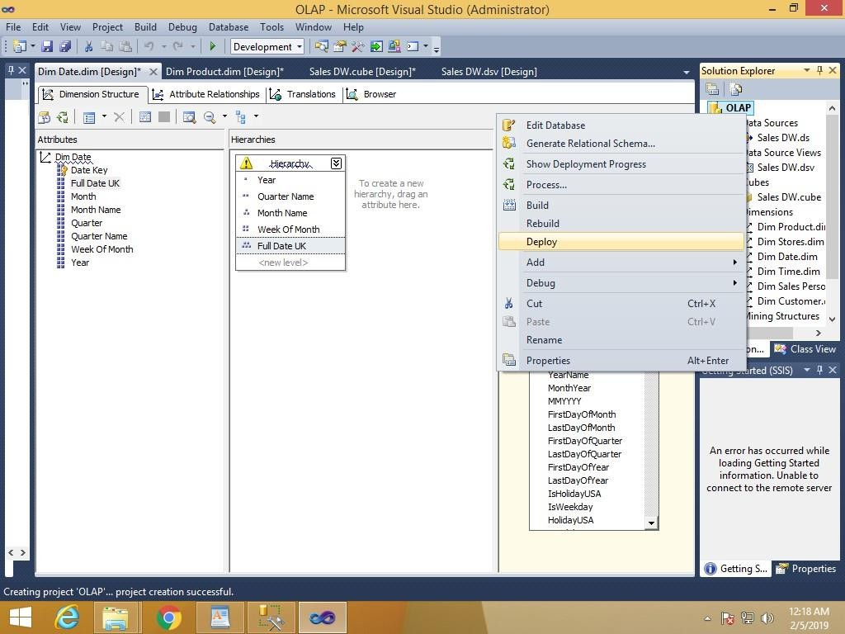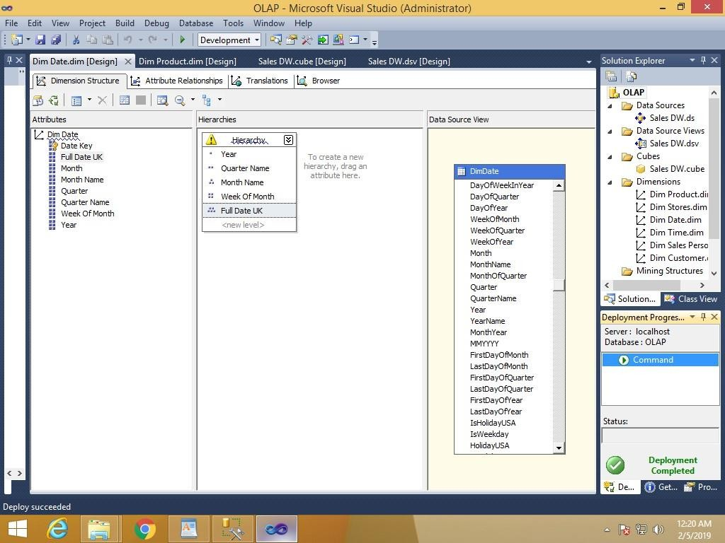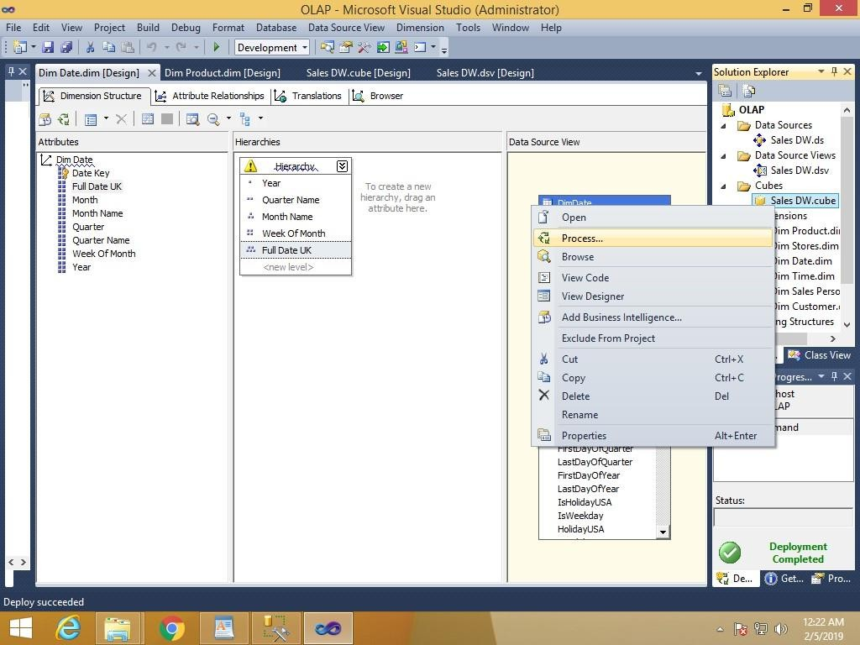

To process cube right click on Sales_DW.cube → Process

Click run

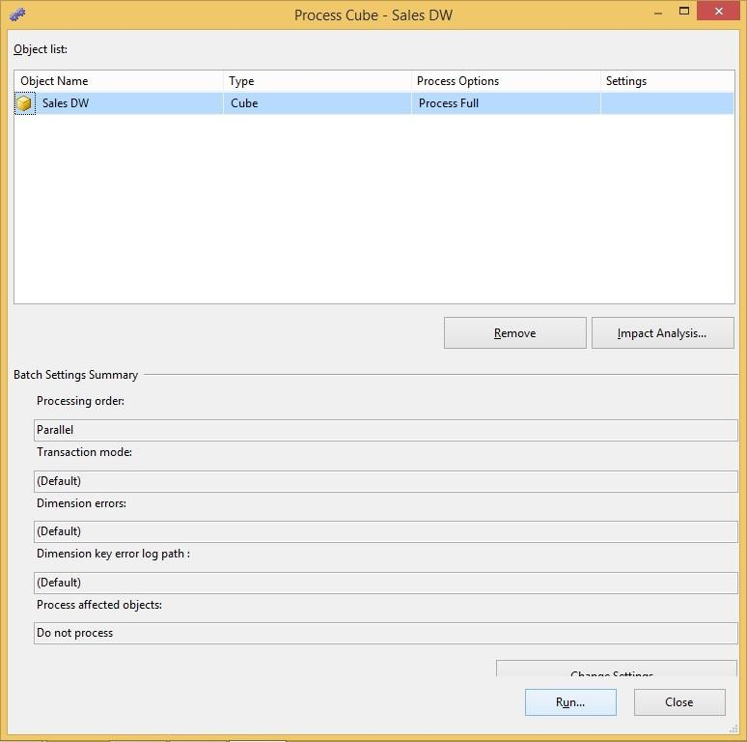

Browse the cube for analysis in solution explorer

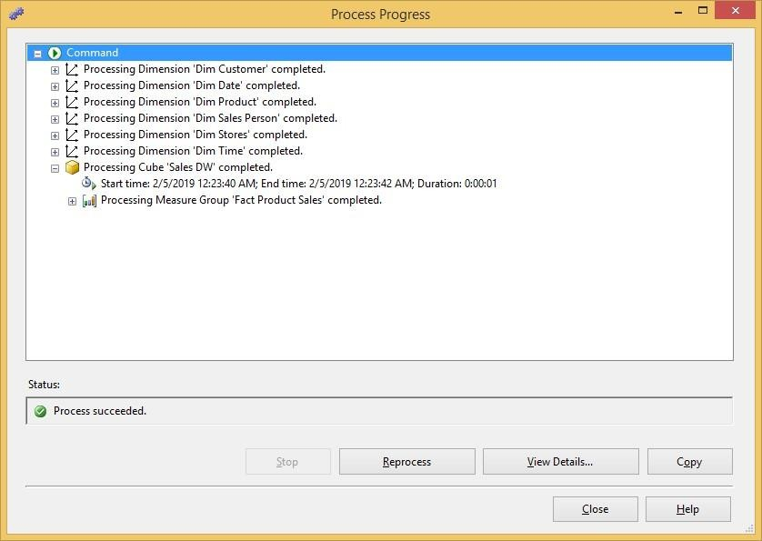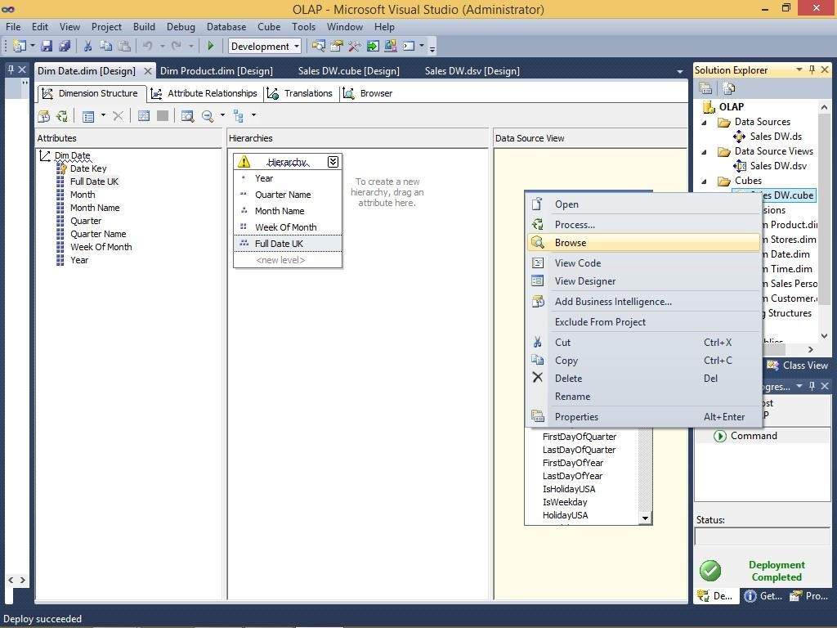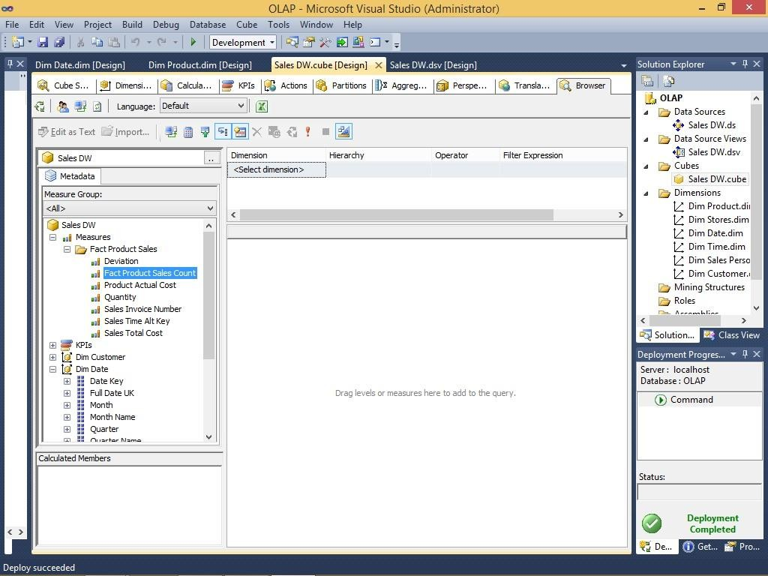

**Learning Outcomes:**

**Course Outcomes:**

**Conclusion:**

**Viva Questions:**

1. **Define staging.**
2. **Why is staging important?**
3. **Name one staging component.**
4. **How to validate data in staging?**

**For Faculty use:**

|  |  |  |  |
| --- | --- | --- | --- |
| Correction Parameters | Formative Assessment[40%] | Timely Completion of Practical[40%] | Attendance Learning Attitude[20%] |
|  |  |  |  |



**Aims:**

1. To design an ETL map outlining the flow of data from source systems to the data warehouse.



**SHRI GPM DEGREE COLLEGE OF SCIENCE & COMMERCE**

Department of Computer

**Affiliated to University of Mumbai**

Vision.. Innovation.. Solution.. Presentation..



**Practical-4: a. Create the ETL map and setup the schedule for execution.**

**– b. Execute the MDX queries to extract the data from data ware house.**



1. To set up and schedule the ETL process for automated execution.
2. To execute MDX queries for extracting and analyzing data from the data warehouse**.**

# Learning Objectives:

1. Understand the principles of ETL mapping and how it drives data integration.
2. Gain hands-on experience in scheduling ETL jobs to ensure timely data processing.
3. Learn to write and execute MDX queries to extract multidimensional data for reporting and analysis.
4. Evaluate the effectiveness and performance of the ETL process and query results.

# Tool & Technologies used:

1. Power BI is a powerful business intelligence tool used for data visualization and analysis.

# Theory-4: ETL

ETL (Extract, Transform, Load) is a core process in data warehousing that integrates data from multiple

sources into a centralized repository. This theory focuses on two key aspects: designing an ETL map with an execution schedule and using MDX queries to extract data from the data warehouse.



**Creating the ETL Map and Scheduling Execution**

1. **Designing the ETL Map**
   * **Source Identification:** Identify all relevant data sources (databases, files, APIs) and understand their formats and structures.
   * **Mapping Data Flow:** Create a visual map that outlines the flow of data from source systems to the staging area, detailing transformation steps and the final load into the data warehouse.
   * **Defining Transformation Rules:** Document the business rules needed for data cleansing, conversion, aggregation, and enrichment.
   * **Error Handling:** Establish procedures for logging errors, issuing alerts, and rolling back transactions if issues occur during the ETL process.
2. **Scheduling the ETL Process**
   * **Determining Frequency:** Decide whether the ETL jobs should run in batch mode (e.g., nightly, hourly) or in real time, based on data freshness requirements and system load.
   * **Automation:** Utilize ETL automation tools (such as SQL Server Integration Services, Informatica, or Apache NiFi) to schedule and execute jobs reliably.





* **Monitoring and Alerts:** Set up monitoring dashboards and notification systems to track job performance and address any failures promptly.

**Executing MDX Queries to Extract Data from the Data Warehouse**

1. **Understanding MDX:**
   * MDX (Multidimensional Expressions) is a query language designed for OLAP (Online

Analytical Processing) systems. It enables the retrieval and analysis of multidimensional data stored in cubes.

* + MDX queries help extract aggregated, detailed, or time-series data across various dimensions like product, geography, and time.

1. **Running MDX Queries:**
   * **Connection:** Establish a secure connection to the OLAP data warehouse.
   * **Query Construction:** Build MDX queries to retrieve relevant data. For example, a query to

extract total sales by product category for the year 2024 might look like this:

* + **Result Analysis:** Analyze the query results to generate actionable insights, support reporting, and enable dynamic data visualizations.

PRACTICAL 4 b

Execute the MDX queries to extract the data from the datawarehouse.

Step 1: Open SQL Server Management Studio and connect to Analysis Services. Server type: Analysis Services

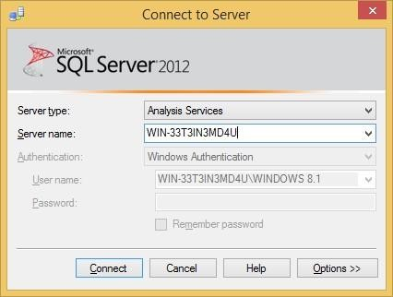

Server Name: (according to base machine)

Click on connect

Step 2: Click on New Query & type following query based on Sales_DW

select [Measures].[Sales Time Alt Key] on columns from [Sales DW] Click on

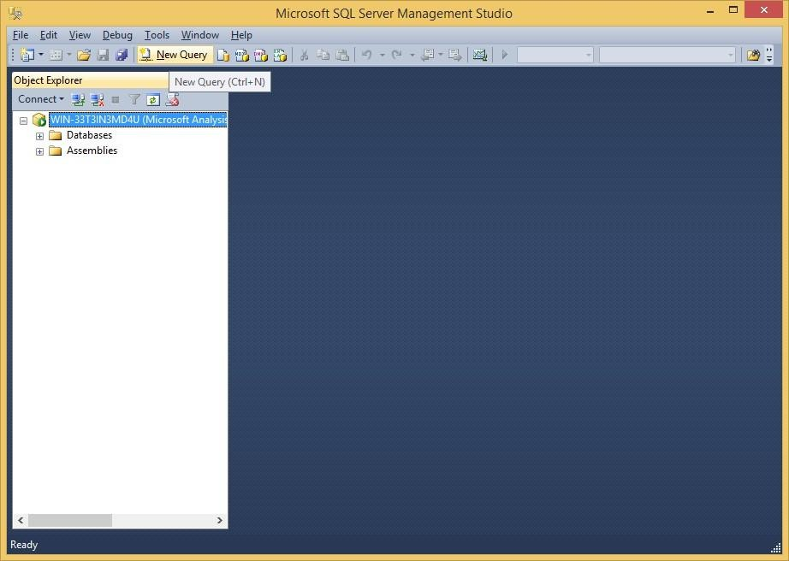

execute

select [Measures].[Quantity] on columns from [Sales DW]

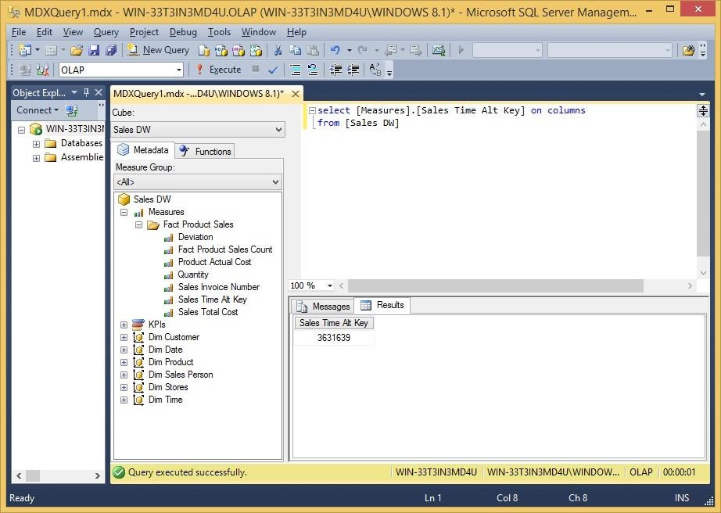

select [Measures].[Sales Invoice Number] on columns from [Sales DW]

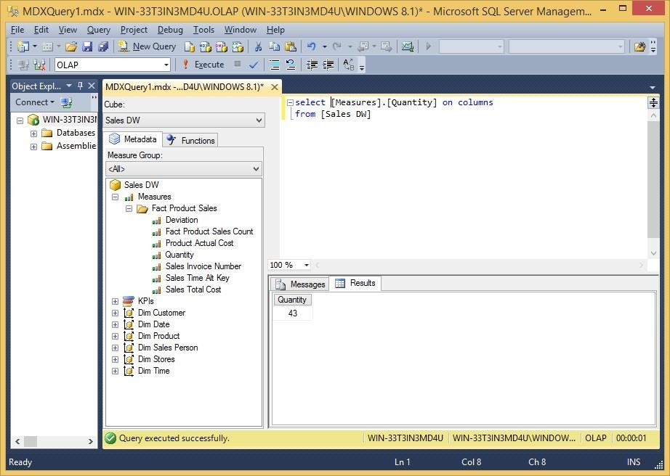

select [Measures].[Sales Total Cost] on columns from [Sales DW]

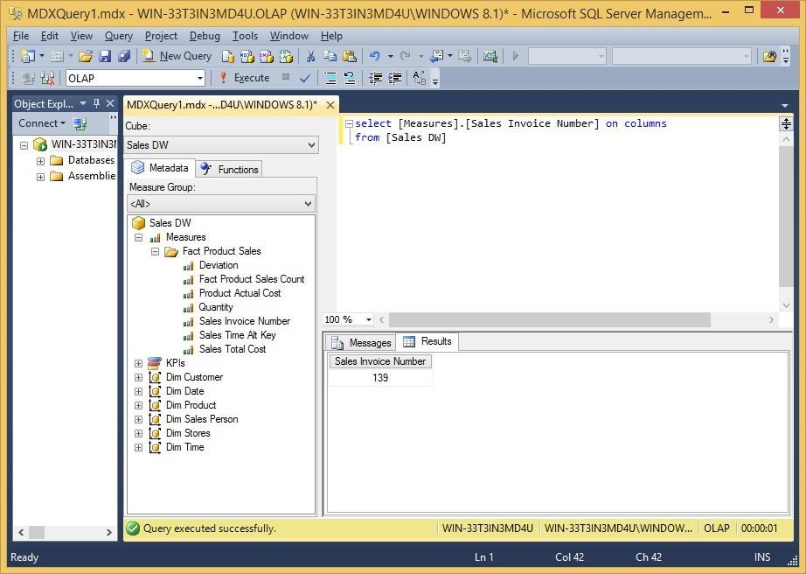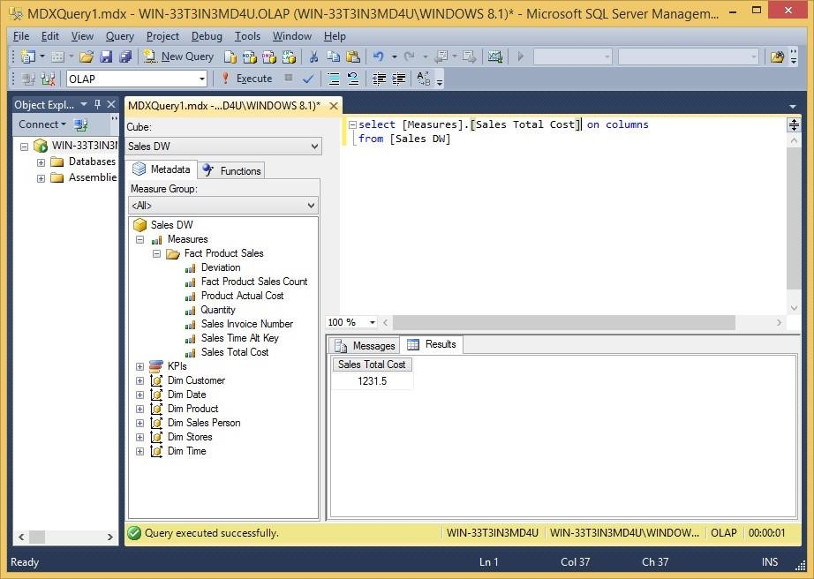

select [Measures].[Sales Total Cost] on columns

, [Dim Date].[Year].[Year] on rows from [Sales DW]

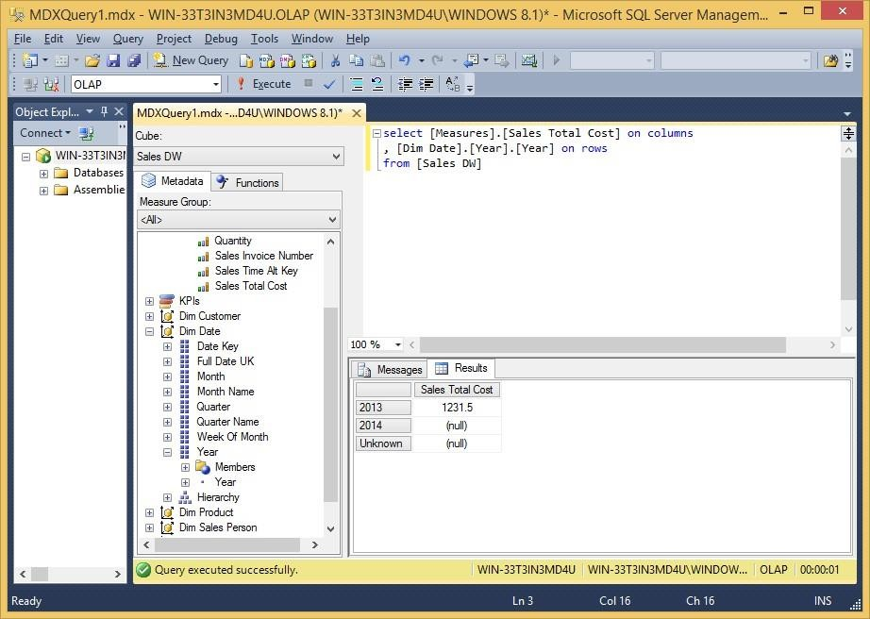

select [Measures].[Sales Total Cost] on columns , NONEMPTY({[Dim Date].[Year].[Year]}) on rows from [Sales DW]

select [Measures].[Sales Total Cost] on columns from [Sales DW] Where [Dim Date].[Year].[Year].&[2013]

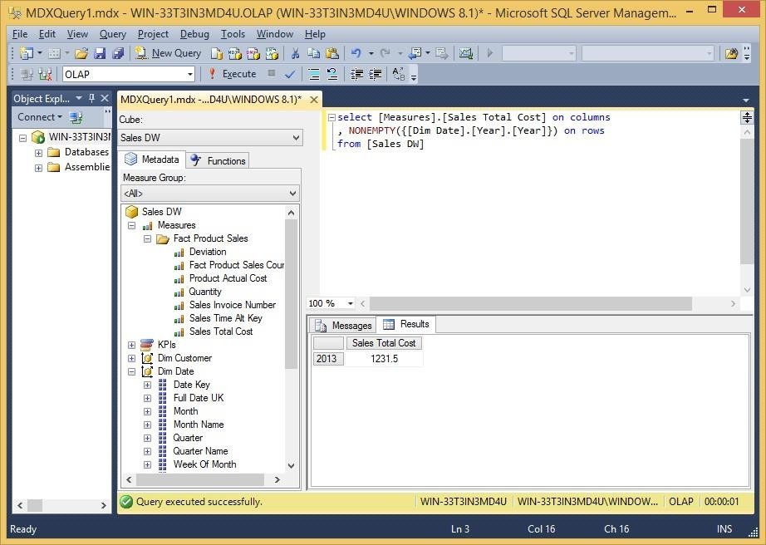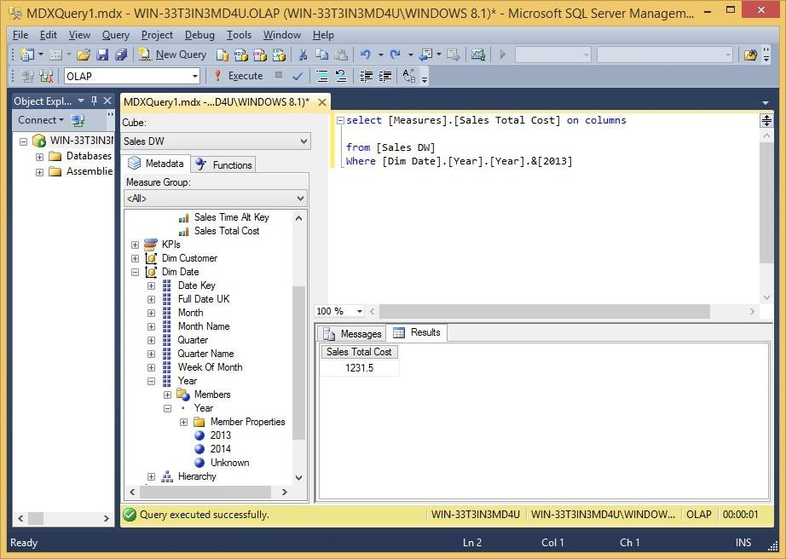

**Learning Outcomes:**

**Course Outcomes:**

**Conclusion:**

**Viva Questions:**

1. **What is ETL?**
2. **Name the three steps in ETL.**
3. **Why is ETL important?**
4. **Name an ETL tool.**

**For Faculty use:**

|  |  |  |  |
| --- | --- | --- | --- |
| Correction Parameters | Formative Assessment[40%] | Timely Completion of Practical[40%] | Attendance Learning Attitude[20%] |
|  |  |  |  |



**SHRI GPM DEGREE COLLEGE OF SCIENCE & COMMERCE**

Department of Computer

**Affiliated to University of Mumbai**

Vision.. Innovation.. Solution.. Presentation..



1. **Import the data ware house data in Micros Excel and create the Pivot table and PivotChart.**
2. **Import the cube in Microsoft Excel and create- the Pivot table and Pivot Chart to perform data analysis.**



**Practical-5:**



**Aims:**



1. To import data from a data warehouse into Microsoft Excel and create PivotTables and PivotCharts for effective data analysis.
2. To import a multidimensional cube into Excel and use its interactive features to analyze data through PivotTables and Pivot Charts.

**Learning Objectives:**

* 1. Understand how to connect Excel to a data warehouse and cube.
  2. Learn to create and customize PivotTables and Pivot Charts to summarize and visualize data.
  3. Develop skills in analyzing large datasets and deriving actionable insights using Excel’s data analysis

tools.

**Tool & Technologies used:**

* + 1. Power BI is a powerful business intelligence tool used for data visualization and analysis.



**Theory-5: Data ware house**



Data warehousing consolidates data from various sources into a centralized repository, enabling efficient analysis and reporting. Microsoft Excel serves as a versatile tool for importing data, creating PivotTables, and generating PivotCharts, which empower users to explore and visualize complex datasets.



**A. Importing Data Warehouse Data into Microsoft Excel**

1. **Data Importation:**
   * Utilize Excel’s Data tab to establish a connection to the data warehouse using options like ODBC, SQL Server, or other database connectors.
   * Configure the connection to securely access the required tables or views from the warehouse.
2. **Creating a PivotTable:**
   * Once the data is imported, go to the Insert tab and select PivotTable to initiate a new PivotTable based on the imported data.
   * Organize the data by dragging and dropping fields into Rows, Columns, Values, and Filters, enabling a multidimensional view of the data.



1. **Generating a PivotChart:**
   * With the PivotTable in place, use the PivotChart feature to create a visual representation of your summarized data.
   * Customize the chart type (bar, line, pie, etc.) to effectively highlight key trends and insights.

**B. Importing the OLAP Cube into Microsoft Excel**

1. **Connecting to the Cube:**
   * In Excel, select Data > Get Data > From Other Sources > From Analysis Services to connect directly to an OLAP cube.
   * Input the necessary server and database credentials to access the multidimensional data.
2. **Building a PivotTable from the Cube:**
   * Excel will automatically present the cube’s dimensions and measures.
   * Create a PivotTable by dragging cube fields into the respective areas, leveraging the inherent hierarchical structure for detailed analysis.
3. **Creating a PivotChart for Cube Data:**
   * After setting up the PivotTable, insert a PivotChart to visualize the aggregated cube data.
   * Utilize interactive features like drill-downs to explore underlying data and uncover hidden insights.

PRACTICAL 5 a

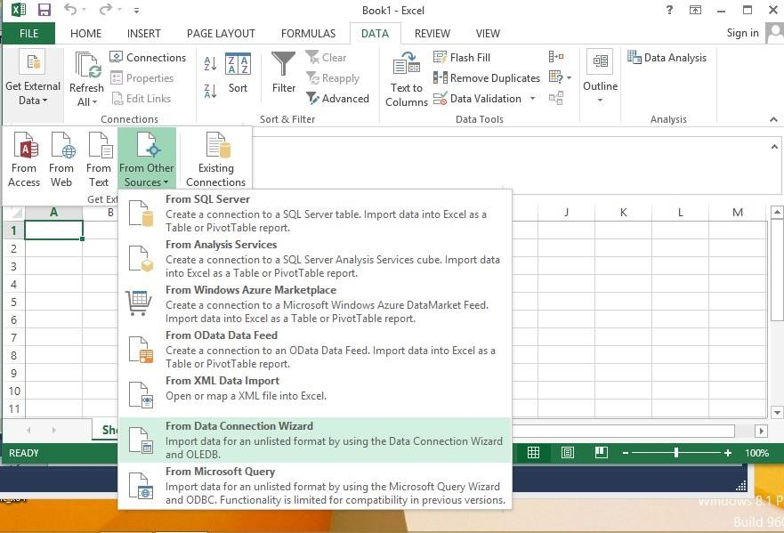

Go to Data tab → Get External Data → From Other Sources → From Data Connection Wizard

Step 2: In Data Connection Wizard → Select Microsoft SQL Server → Click on Next

Import the datawarehouse data in Microsoft Excel and create the Pivot table and Pivot Chart (Ms Office Professional is used to make sure Power View is enabled for visualization.)

Step 1: Open Excel 2013 (Professional)

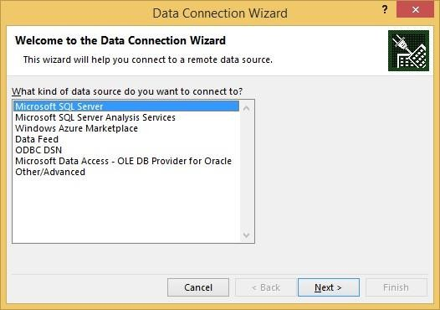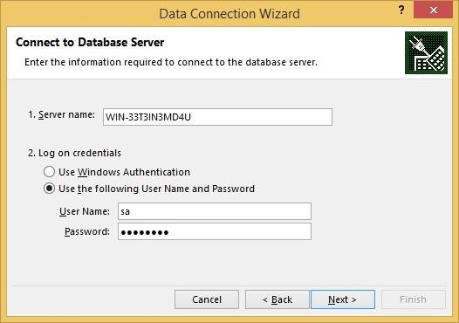

Step 3: In connect to Database Server provide Server name( Microsoft SQL Server Name) Provide password for sa account as given during installation of SQL Server 2012 full version) Password: admin123

Click on Next

Step 4: In Select Database and Table→ Select Sales_DW (already created in SQL) → check all dimensions and import relationships between selected tables

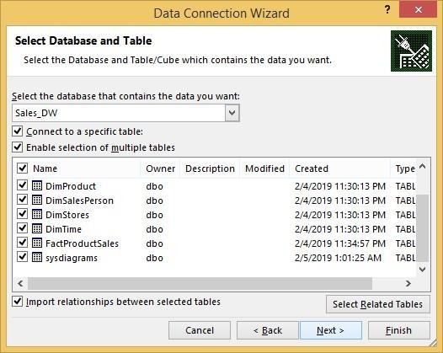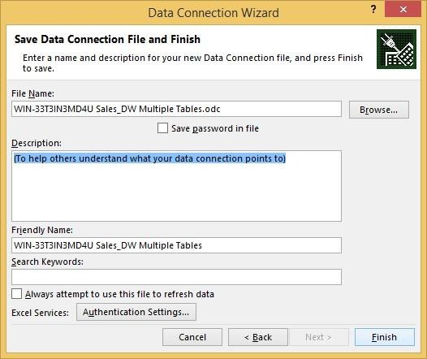

Step 5: In save data connection files browse path and click on Finish

Step 6: In import data select Pivot Chart and click on OK

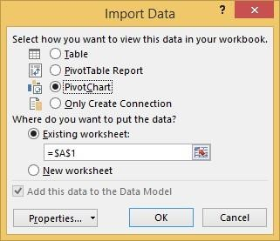

Step 7: In fields put SalesDateKey in filters, FullDateUK in axis and Sum of ProductActualCost in values

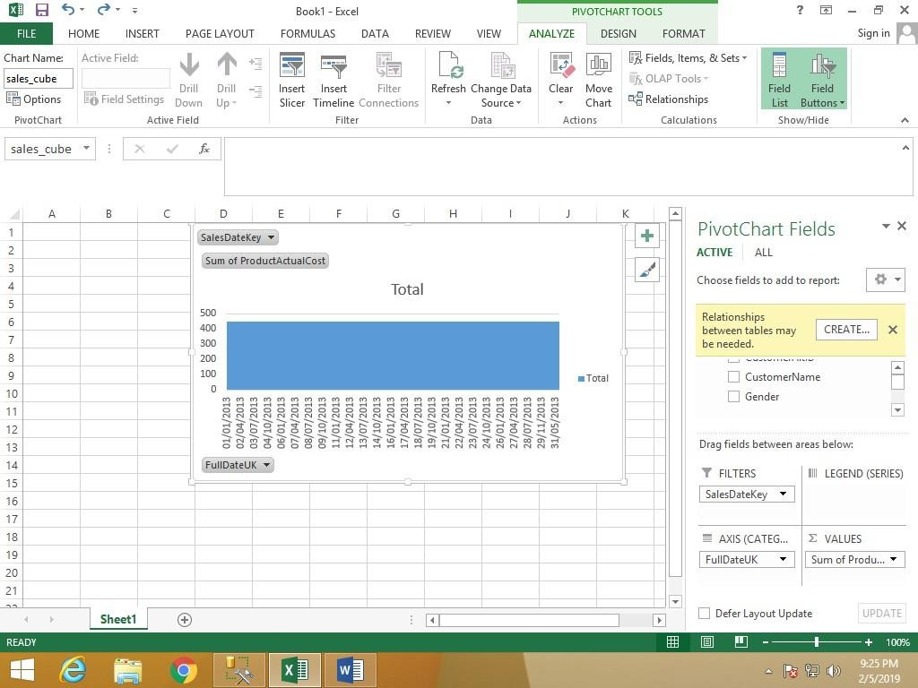

Step 8: In Insert Tab → go to Pivot Table

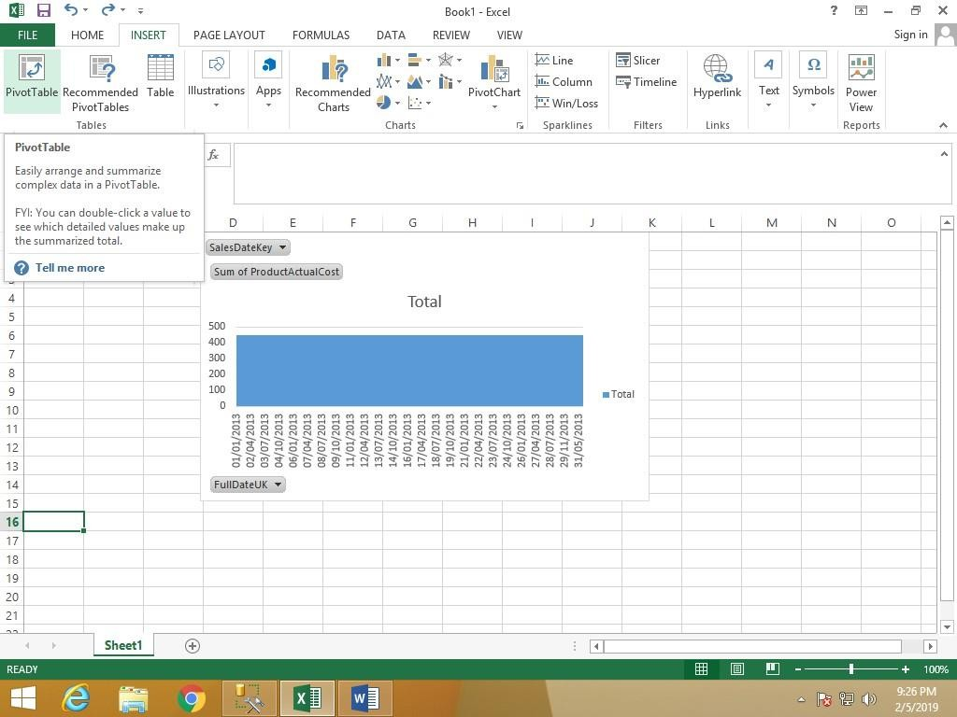

Step 9: Click on Choose Connection to select existing connection with Sales_DW and click on open

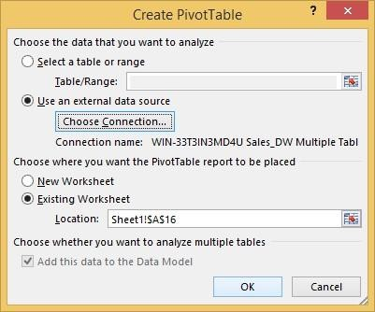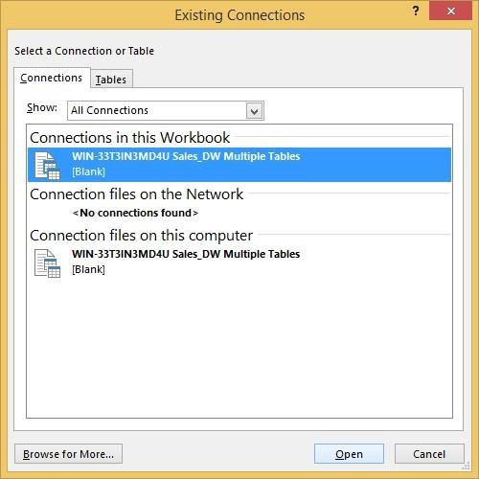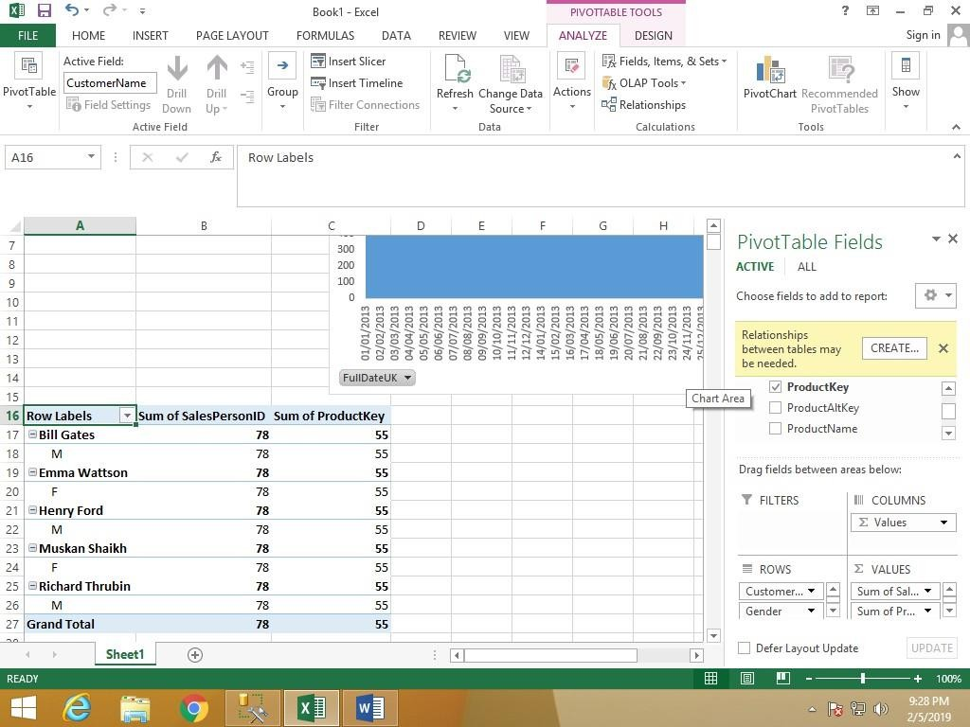

Pivot table and Pivot chart is created

**Learning Outcomes:**

**Course Outcomes:**

**Conclusion:**

**Viva Questions:**

1. **What is a data warehouse?**
2. **Name a key feature of a data warehouse.**
3. **Why are data warehouses used?**
4. **What is the difference between OLTP and OLAP?**

**For Faculty use:**

|  |  |  |  |
| --- | --- | --- | --- |
| Correction Parameters | Formative Assessment[40%] | Timely Completion of Practical[40%] | Attendance Learning Attitude[20%] |
|  |  |  |  |





**SHRI GPM DEGREE COLLEGE OF SCIENCE & COMMERCE**

Department of Computer

**Affiliated to University of Mumbai**

Vision.. Innovation.. Solution.. Presentation..



**Practical-6: Apply the what – if Analysis for data visualization. Design and generate necessary reports based on the data ware house data.**



**Aims:**



1. To apply what-if analysis techniques to simulate various business scenarios using data warehouse data.
2. To design and generate dynamic reports that help in understanding potential outcomes and supporting decision-making.

**Learning Objectives:**

* 1. Understand the concept and benefits of what-if analysis in a data warehousing context.
  2. Learn to configure and manipulate what-if parameters to simulate changes in key business metrics.
  3. Gain hands-on experience in designing interactive dashboards and reports that reflect hypothetical scenarios.
  4. Develop skills in interpreting data-driven insights to inform business strategies.

**Tool & Technologies used:**

* + 1. Power BI is a powerful business intelligence tool used for data visualization and analysis.



**Theory-6: Data ware house data**



Data warehouses consolidate information from diverse sources, creating a centralized repository for strategic decision-making. Applying what-if analysis enables analysts to simulate different scenarios, assess potential impacts, and visualize outcomes. This approach transforms raw data into actionable insights, guiding

strategic planning and operational improvements.



**What-If Analysis for Data Visualization**

* **Definition:**

What-if analysis involves modifying key input variables to explore alternative outcomes. It helps identify risks, forecast trends, and understand the sensitivity of various business metrics.

* **Techniques and Tools:**

Utilize tools like Microsoft Excel, Power BI, or Tableau to perform scenario analysis. These tools support dynamic simulations using data models, adjustable parameters, and interactive dashboards.

* **Application Areas:**





* **Financial Forecasting:** Model revenue or expense changes under different economic conditions.
* **Sales Projections:** Analyze the impact of pricing strategies or market fluctuations on sales volumes.
* **Resource Allocation:** Predict outcomes of different staffing or inventory levels.



**Designing and Generating Reports**

1. **Data Preparation and Integration:**
   * Import data warehouse records into Excel or a BI tool using secure connections (e.g., ODBC, SQL Server connectors).
   * Cleanse and aggregate the data to ensure accuracy for analysis.
2. **Report Layout and Structure:**
   * **Interactive Dashboards:** Create dashboards that integrate PivotTables, PivotCharts, and slicers to allow dynamic filtering.
   * **Custom Metrics:** Incorporate key performance indicators (KPIs) tailored to the business context, such as profit margins, growth rates, or cost variances.

PRACTICAL 6

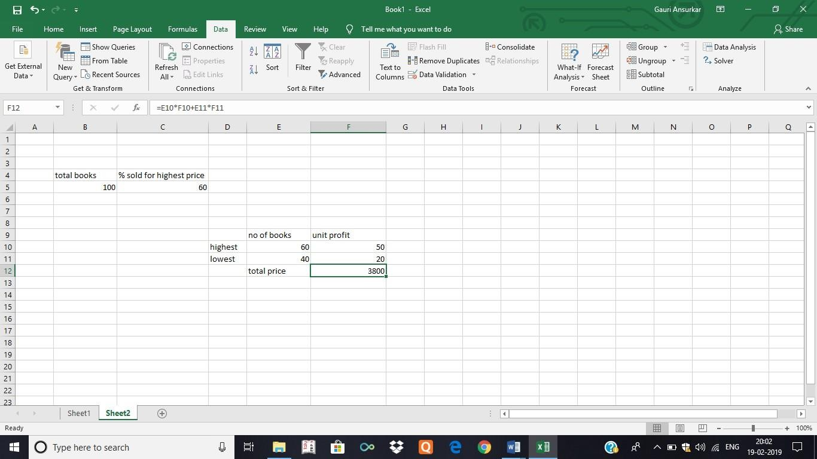

Apply the what – if Analysis for data visualization. Design and generate necessary reports based on the data warehouse data.

A book store and have 100 books in storage. You sell a certain % for the highest price of $50 and a certain % for the lower price of $20.

If you sell 60% for the highest price, cell D10 calculates a total profit of 60 * 50 + 40 * 20 = 3800.

Create Different Scenarios But what if you sell 70% for the highest price? And what if you sell 80% for the highest price? Or 90%, or even 100%? Each different percentage is a different scenario. You can use the Scenario Manager to create these scenarios.

Note: To type different percentage into cell C4 to see the corresponding result of a scenario in cell D10 we use what if analysis.

What-if analysis enables you to easily compare the results of different scenarios.

Step 1: In Excel, On the Data tab, in the Data tools group, click What-If Analysis

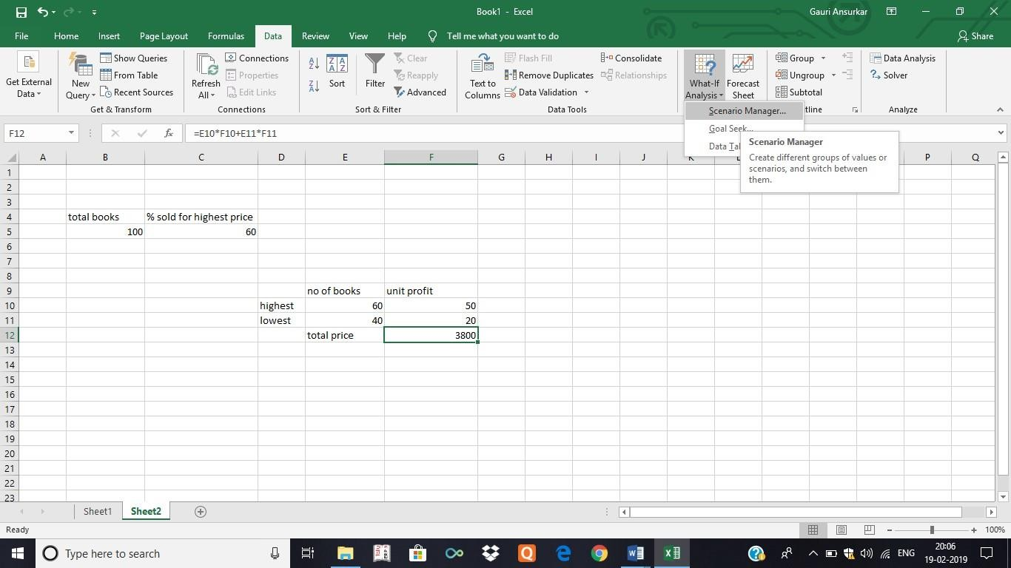

Step 2: Click on What –if-Analysis and select scenario manager.

The Scenario Manager Dialog box appears. Step 3: Add a scenario by clicking on Add.

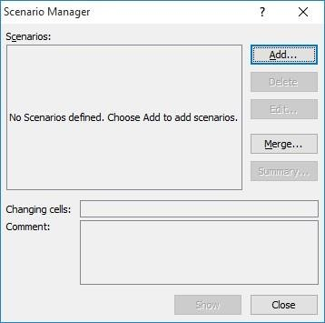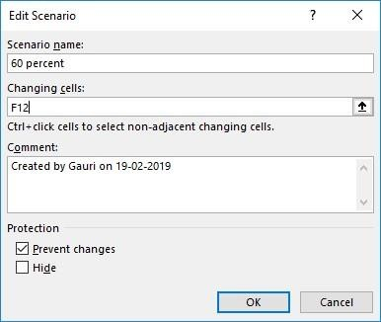

Step 4: Type a name (60percent), select cell F10 (% sold for the highest price) for the Changing cells and click on OK.

Click on icon which is circled.

Select F10 cell.

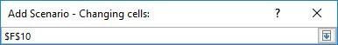

Click back on the icon again and then click OK

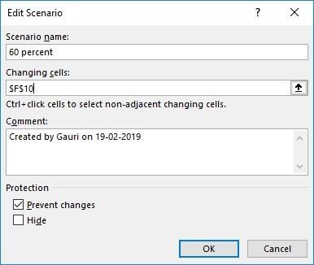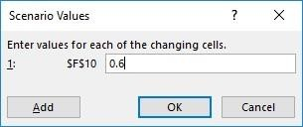

Step 5: Enter the corresponding value 0.6 and click on OK again.

Step 6: To apply scenarios click on Show

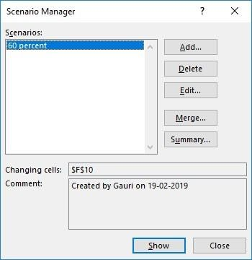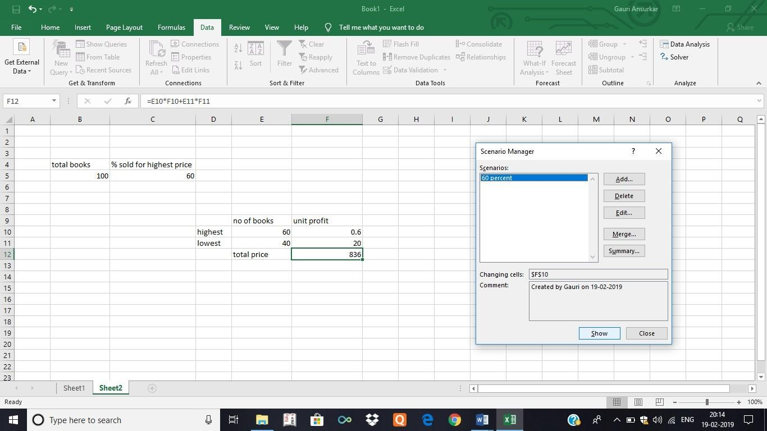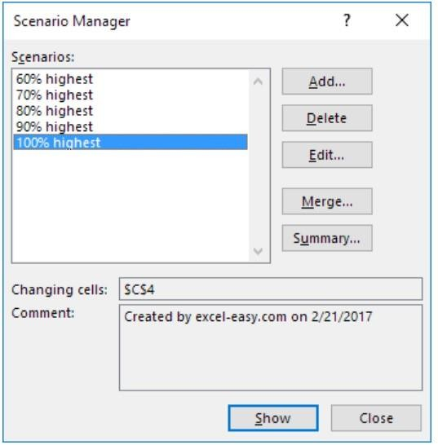

Step 7: Next, add 4 other scenarios (70%, 80%, 90% and 100%)

Finally, your Scenario Manager should be consistent with the picture below:

**Learning Outcomes:**

**Course Outcomes:**

**Conclusion:**

**Viva Questions:**

1. **What is data warehousing?**
2. **Define data warehouse data.**
3. **Why is data warehousing important?**
4. **Data warehouse vs. database?**

**For Faculty use:**

|  |  |  |  |
| --- | --- | --- | --- |
| Correction Parameters | Formative Assessment[40%] | Timely Completion of Practical[40%] | Attendance Learning Attitude[20%] |
|  |  |  |  |





**SHRI GPM DEGREE COLLEGE OF SCIENCE & COMMERCE**

Department of Computer

**Affiliated to University of Mumbai**

Vision.. Innovation.. Solution.. Presentation..



**Practical-7: Perform the data classification using classification algorithm**



**Aims:**



1. To apply classification algorithms for categorizing data into predefined classes.
2. To understand how data classification supports predictive analytics and decision-making.

**Learning Objectives:**

* 1. Comprehend the fundamental concepts and techniques in classification within data mining and machine learning.
  2. Gain hands-on experience in implementing classification algorithms using programming libraries.
  3. Evaluate model performance through metrics such as accuracy, precision, recall, and F1 score.
  4. Develop skills in data preprocessing, model training, and interpretation of classification results.

**Tool & Technologies used:**

* + 1. Power BI is a powerful business intelligence tool used for data visualization and analysis.



**Theory-7: Classification**



Data classification is a supervised machine learning technique aimed at categorizing data into predefined classes or labels. By analyzing historical, labeled data, classification algorithms learn patterns and

relationships, enabling them to accurately predict the class of new, unseen instances.

**Process of Data Classification**



1. **Data Preparation**
   * **Collection & Cleaning:** Gather a representative dataset and clean it by handling missing values, removing outliers, and correcting errors.
   * **Feature Selection & Engineering:** Identify key features that influence the classification

outcome and transform raw data into a suitable format for analysis.

1. **Dataset Partitioning**
   * **Training Set:** Allocate a portion of the data to train the classification model, ensuring it learns the underlying patterns.
   * **Test Set:** Reserve another portion to validate and evaluate the model’s performance, thereby preventing overfitting.
2. **Algorithm Selection**





* Choose an appropriate classification algorithm based on the nature of the data and problem requirements. Common choices include:
  + **Decision Trees:** Offer intuitive, rule-based classification.
  + **Naive Bayes:** Uses probabilistic reasoning for efficient classification.
  + **Support Vector Machines (SVM):** Effective in high-dimensional feature spaces.
  + **K-Nearest Neighbors (KNN):** A simple, instance-based approach.

1. **Model Training and Evaluation**
   * **Training:** Input the training data into the selected algorithm to develop a predictive model.
   * **Evaluation:** Use performance metrics—such as accuracy, precision, recall, and F1 score—to assess how well the model classifies new data using the test set.
2. **Optimization and Deployment**
   * **Parameter Tuning:** Employ techniques like cross-validation and grid search to optimize

model parameters and enhance performance.

* + **Deployment:** Once validated, deploy the model to classify incoming data in real-time or batch processes, ensuring it continuously supports decision-making with up-to-date

predictions.

PRACTICAL 7

Perform the data classification using classification algorithm. OR

Data Analysis using Time Series Analysis Software required: R 3.5.1

Time series is a series of data points in which each data point is associated with a timestamp. A simple example is the price of a stock in the stock market at different points of time on a given day. Another example is the amount of rainfall in a region at different months of the year. R language uses many functions to create, manipulate and plot the time series data. The data for the time series is stored in an R object called time-series object. It is also a R data object like a vector or data frame.

The time series object is created by using the ts() function. Syntax

The basic syntax for ts() function in time series analysis is − timeseries.object.name <- ts(data, start, end, frequency)

Following is the description of the parameters used −

* data is a vector or matrix containing the values used in the time series.
* start specifies the start time for the first observation in time series.
* end specifies the end time for the last observation in time series.
* frequency specifies the number of observations per unit time. Except the parameter "data" all other parameters are optional

Consider the annual rainfall details at a place starting from January 2012. We create an R time series object for a period of 12 months and plot it.

Code to run in R

# Get the data points in form of a R vector.

rainfall <- c(799,1174.8,865.1,1334.6,635.4,918.5,685.5,998.6,784.2,985,882.8,1071)

# Convert it to a time series object.

rainfall.timeseries <- ts(rainfall,start = c(2012,1),frequency = 12)

# Print the timeseries data. print(rainfall.timeseries)



# Plot a graph of the time series.

plot(rainfall.timeseries)

# Save the file.

dev.off()

After this again plot to get chart plot(rainfall.timeseries)

Output:

When we execute the above code, it produces the following result and chart − Jan Feb Mar Apr May Jun Jul Aug Sep 2012 799.0 1174.8

865.1 1334.6 635.4 918.5 685.5 998.6 784.2 Oct Nov Dec 2012 985.0 882.8 1071.0

# Give the chart file a name. png(file = "rainfall.png")

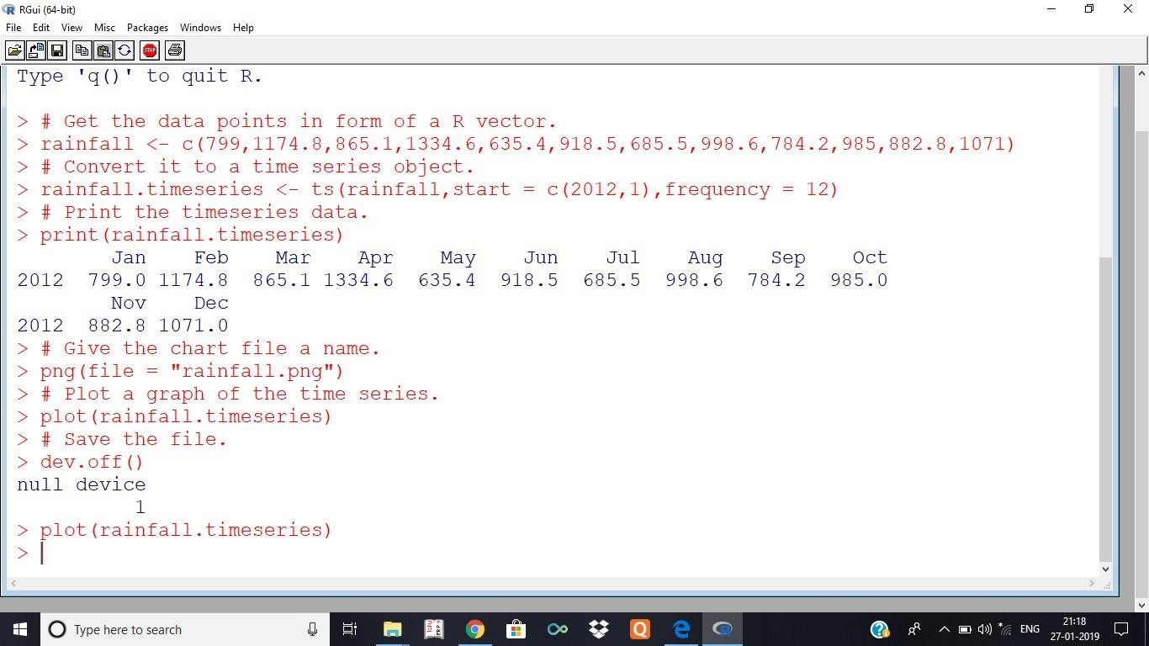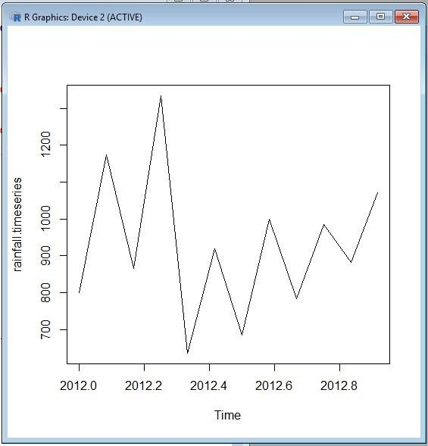

**Learning Outcomes:**

**Course Outcomes:**

**Conclusion:**

**Viva Questions:**

1. **What is classification?**
2. **What is supervised classification?**
3. **Why is classification important?**
4. **Example of a classification task?**

**For Faculty use:**

|  |  |  |  |
| --- | --- | --- | --- |
| Correction Parameters | Formative Assessment[40%] | Timely Completion of Practical[40%] | Attendance Learning Attitude[20%] |
|  |  |  |  |





**SHRI GPM DEGREE COLLEGE OF SCIENCE & COMMERCE**

Department of Computer

**Affiliated to University of Mumbai**

Vision.. Innovation.. Solution.. Presentation..



**Practical-8: Perform the data clustering using clustering algorithm.**



**Aims:**



1. To understand the fundamentals of clustering and its application in grouping similar data points.
2. To discover inherent patterns and segments within datasets using unsupervised learning techniques.

**Learning Objectives:**

* 1. Comprehend the basic concepts of unsupervised learning and clustering methods.
  2. Gain hands-on experience with popular clustering algorithms such as K-means and hierarchical clustering.
  3. Learn how to preprocess, analyze, and visualize data for effective clustering.
  4. Evaluate the quality of clusters using metrics like silhouette scores.

**Tool & Technologies used:**

* + 1. Power BI is a powerful business intelligence tool used for data visualization and analysis.



**Theory-8: Clustering**



Clustering is an unsupervised learning technique that groups similar data points into clusters, uncovering inherent structures in the dataset without predefined labels. This approach is useful for segmenting data, discovering patterns, and reducing data complexity in areas such as market segmentation, anomaly

detection, and image analysis.



**Process of Data Clustering**

1. **Data Preparation**
   * **Data Collection & Cleaning:** Gather a comprehensive dataset and clean it by removing

noise, handling missing values, and eliminating outliers.

* + **Normalization & Scaling:** Standardize or normalize features to ensure that no single feature dominates the clustering due to scale differences.

1. **Feature Selection and Extraction**
   * **Feature Selection:** Identify key variables that capture the essence of the data, ensuring that the chosen features enhance the distinction between clusters.
   * **Dimensionality Reduction:** Apply techniques such as Principal Component Analysis (PCA) if necessary to reduce dimensionality while preserving important information.
2. **Algorithm Selection**





* **K-Means:** A widely used algorithm that partitions data into k clusters by minimizing the variance within each cluster.
* **Hierarchical Clustering:** Builds a tree of clusters (dendrogram) and does not require specifying the number of clusters upfront.
* **DBSCAN:** Groups data points based on density, which is effective for discovering clusters of arbitrary shapes and handling noise.

1. **Model Training and Evaluation**
   * **Clustering Execution:** Run the selected algorithm on the prepared dataset. For example, with K-Means, choose an initial value for k and iterate until the cluster centroids stabilize.
   * **Cluster Validation:** Evaluate the quality of the clusters using metrics such as silhouette scores, Davies-Bouldin index, or within-cluster sum of squares (WCSS).
   * **Parameter Tuning:** Adjust parameters (like the number of clusters in K-Means or the

neighborhood radius in DBSCAN) to refine cluster quality.

PRACTICAL 8

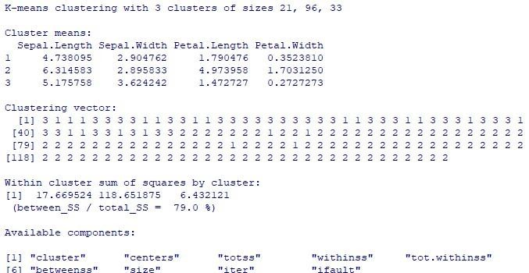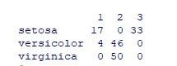

Perform the data clustering using clustering algorithm. k-means clustering using R

#apply K means to iris and store result newiris <- iris

newiris$Species <- NULL (kc <- kmeans(newiris,3))

#Compare the Species label with the clustering result table(iris$Species,kc$cluster)

#Plot the clusters and their centers

plot(newiris[c("Sepal.Length","Sepal.Width")],col=kc$cluster) points(kc$centers[,c("Sepal.Length","Sepal.Width")],col=1:3,pch=8,cex=2) dev.off()

#Plot the clusters and their centre plot(newiris[c("Sepal.Length","Sepal.Width")],col=kc$cluster)

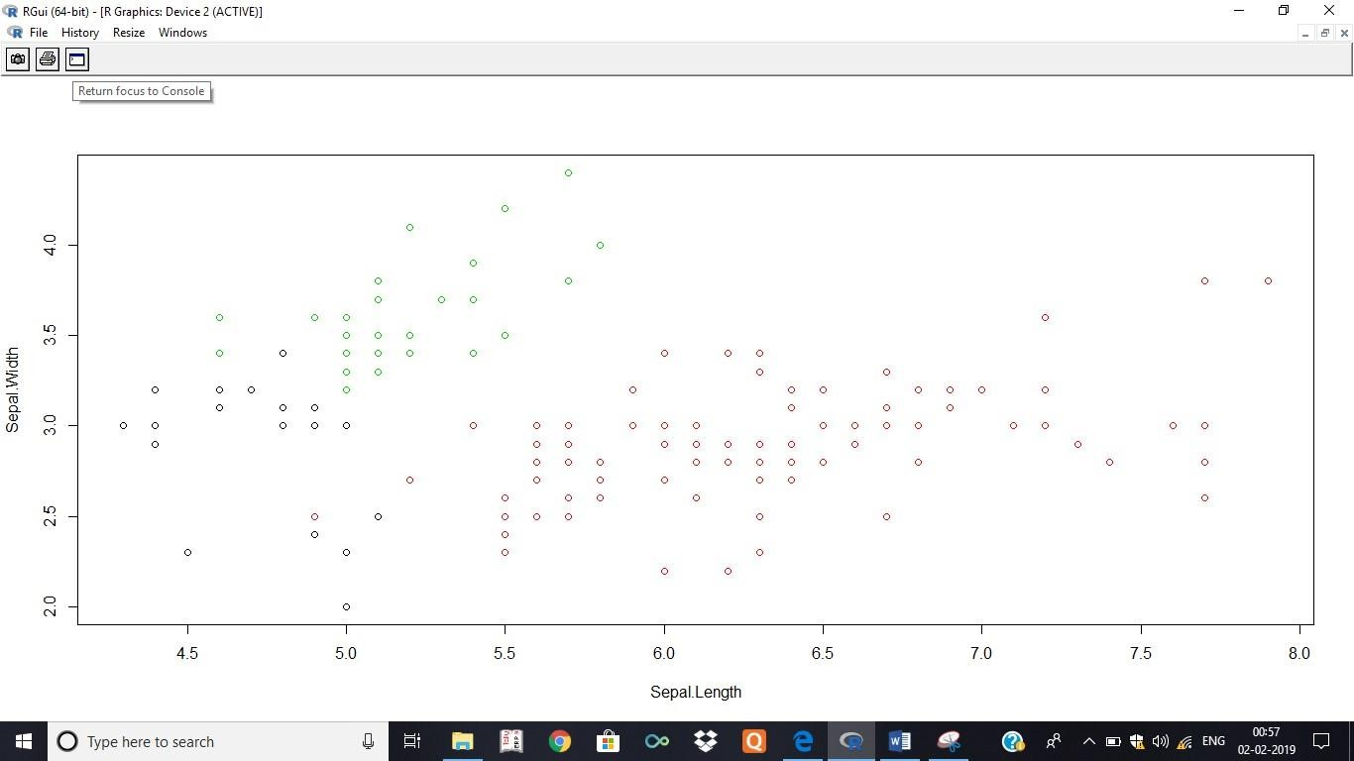

**Learning Outcomes:**

**Course Outcomes:**

**Conclusion:**

**Viva Questions:**

1. **What is clustering?**
2. **Name a clustering algorithm.**
3. **What is the purpose of clustering?**
4. **Difference between clustering and classification?**

**For Faculty use:**

|  |  |  |  |
| --- | --- | --- | --- |
| Correction Parameters | Formative Assessment[40%] | Timely Completion of Practical[40%] | Attendance Learning Attitude[20%] |
|  |  |  |  |





**SHRI GPM DEGREE COLLEGE OF SCIENCE & COMMERCE**

Department of Computer

**Affiliated to University of Mumbai**

Vision.. Innovation.. Solution.. Presentation..



**Practical-9: Perform the Linear regression on the given data ware house data.**



**Aims:**



1. To apply linear regression techniques on data extracted from a data warehouse.
2. To forecast relationships between variables and derive predictive insights for informed decision- making.

**Learning Objectives:**

* 1. Understand the fundamental concepts and assumptions of linear regression.
  2. Gain practical experience in preprocessing and cleaning data for regression analysis.
  3. Learn to implement linear regression models using Python and evaluate model performance using metrics such as R-squared, Mean Absolute Error (MAE), and Mean Squared Error (MSE).
  4. Interpret the regression coefficients to assess the impact of independent variables on the target variable.

**Tool & Technologies used:**

* + 1. Power BI is a powerful business intelligence tool used for data visualization and analysis.



**Theory-9: Linear regression**



Linear regression is a statistical method used to model the relationship between a dependent variable and one or more independent variables. It helps identify trends, make predictions, and derive insights from data

warehouse information. This technique is widely used for forecasting, performance analysis, and decision- making in business intelligence.



**Steps to Perform Linear Regression**



**1. Data Preparation and Extraction**



* Extract structured data from the data warehouse using SQL queries or data connectors.
* Identify the target variable (dependent) and relevant predictors (independent variables).
* Perform data cleaning by handling missing values, removing duplicates, and standardizing formats.

**2. Feature Selection and Preprocessing**



* Analyze feature correlations to select the most relevant independent variables.
* Normalize or scale variables if they have different units to improve model accuracy.
* Split the dataset into training and testing subsets (e.g., 80% for training, 20% for testing).

**3. Model Evaluation and Interpretation**





* Assess the model's performance using metrics such as:
  + **R-squared (R²):** Measures how well the model explains the variability in data.
  + **Mean Squared Error (MSE) and Root Mean Squared Error (RMSE):** Evaluate prediction accuracy.
  + **Residual Analysis:** Check for normal distribution and homoscedasticity of residuals.

**4. Prediction and Business Application**

* + 



Apply the trained model to new warehouse data for forecasting and decision-making.

Use insights from the model to optimize business strategies, such as sales predictions, resource allocation, and trend analysis.

* + 



Input Data

Below is the sample data representing the observations –

# Values of height

151, 174, 138, 186, 128, 136, 179, 163, 152, 131

# Values of weight.

63, 81, 56, 91, 47, 57, 76, 72, 62, 48

lm() Function :

This function creates the relationship model between the predictor and the response variable. Syntax :

The basic syntax for lm() function in linear regression is − lm(formula,data) Following is the description of the parameters used :−

* formula is a symbol presenting the relation between x and y.
* data is the vector on which the formula will be applied.

**A.** Create Relationship Model & get the Coefficients # Values

of height x <- c(151, 174, 138, 186, 128, 136, 179, 163, 152, 131)

PRACTICAL 9

Perform the Linear regression on the given data warehouse data.

# Values of width y <- c(63, 81, 56, 91, 47, 57, 76, 72, 62,

48)

# Apply the lm() function. relation <- lm(y~x) print(relation) OUTPUT:

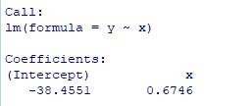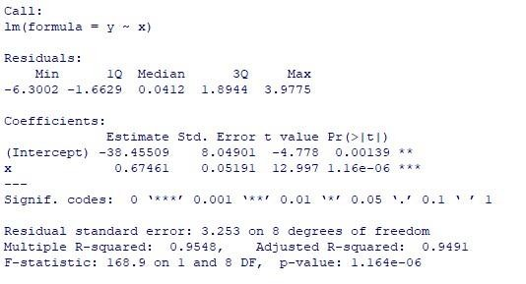

**B.** Get the Summary of the Relationship # Values of height x <-

c(151, 174, 138, 186, 128, 136, 179, 163, 152, 131)

# Values of width y <- c(63, 81, 56, 91, 47, 57, 76, 72, 62,

48)

# Apply the lm() function. relation <-

lm(y~x) print(summary(relation)) OUTPUT:

predict() Function

Syntax

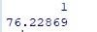

* object is the formula which is already created using the lm() function.
* newdata is the vector containing the new value for predictor variable.

C. Predict the weight of new persons

# The predictor vector.

x <- c(151, 174, 138, 186, 128, 136, 179, 163, 152, 131)

# The response vector. y <- c(63, 81, 56, 91, 47, 57, 76,

72, 62, 48)

# Apply the lm() function.

relation <- lm(y~x)

# Find weight of a person with height 170.

a <- data.frame(x = 170) result <- predict(relation,a) print(result)

OUTPUT:

The basic syntax for predict() in linear regression is − predict(object, newdata) Following is the description of the parameters used −

D. Visualize the Regression Graphically # Create the predictor and response variable. x <- c(151, 174, 138, 186, 128, 136, 179, 163, 152, 131)

y <- c(63, 81, 56, 91, 47, 57, 76, 72, 62, 48) relation <- lm(y~x)

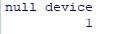

# Plot the chart.

plot(y,x,col = "blue",main = "Height & Weight Regression", abline(lm(x~y)),cex = 1.3,pch = 16,xlab = "Weight in Kg",ylab = "Height in cm")

# Save the file.

dev.off()

# Plot the chart.

plot(y,x,col = "blue",main = "Height & Weight Regression", abline(lm(x~y)),cex = 1.3,pch = 16,xlab = "Weight in Kg",ylab = "Height in cm")

OUTPUT:

# Give the chart file a name. png(file = "linearregression.png")

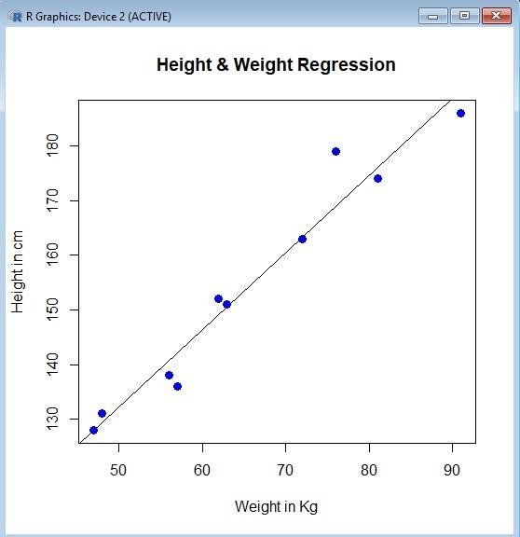

**Learning Outcomes:**

**Course Outcomes:**

**Conclusion:**

**Viva Questions:**

1. **What is linear regression?**
2. **Name one assumption of linear regression.**
3. **What is the purpose of the slope coefficient?**
4. **How is the R-squared value interpreted?**

**For Faculty use:**

|  |  |  |  |
| --- | --- | --- | --- |
| Correction Parameters | Formative Assessment[40%] | Timely Completion of Practical[40%] | Attendance Learning Attitude[20%] |
|  |  |  |  |





**SHRI GPM DEGREE COLLEGE OF SCIENCE & COMMERCE**

Department of Computer

**Affiliated to University of Mumbai**

Vision.. Innovation.. Solution.. Presentation..



**Practical-10: Perform the logistic regression on the given data ware house -data.**



**Aims:**



1. To apply logistic regression techniques on data extracted from a data warehouse for binary classification tasks.
2. To predict the probability of a binary outcome based on multiple predictor variables.

**Learning Objectives:**

* 1. Understand the fundamentals and assumptions of logistic regression.
  2. Gain hands-on experience in preparing and preprocessing data for logistic regression analysis.
  3. Evaluate model performance using metrics such as accuracy, precision, recall, F1-score, and AUC- ROC.
  4. Interpret model coefficients to derive insights for decision-making.

**Tool & Technologies used:**

* + 1. Power BI is a powerful business intelligence tool used for data visualization and analysis.



**Theory-10: logistic regression**



Logistic regression is a statistical and machine learning technique used for classification problems, where

the target variable is categorical (e.g., binary classification: yes/no, success/failure). Unlike linear regression, logistic regression models the probability that an instance belongs to a particular category using the logistic

(sigmoid) function.



**Steps to Perform Logistic Regression**

1. **Data Preparation and Extraction**
   * Extract structured data from the data warehouse using SQL queries or data connectors.
   * Identify the dependent variable (categorical outcome) and independent variables (predictors).
   * Perform data cleaning by handling missing values, standardizing formats, and removing duplicates.
2. **Feature Selection and Preprocessing**
   * Select the most relevant independent variables using correlation analysis.
   * Convert categorical variables into numerical format using encoding techniques (e.g., one-hot encoding).
   * Normalize or scale numerical variables if required.
   * Split the dataset into training and testing subsets (e.g., 80% training, 20% testing).





1. **Model Evaluation and Performance Metrics**
   * **Accuracy Score:** Measures overall correctness of predictions.
   * **Confusion Matrix:** Displays true positives, false positives, true negatives, and false negatives.
   * **Precision, Recall, and F1-Score:** Evaluate classification performance.
   * **ROC Curve & AUC Score:** Analyze the model’s ability to distinguish between classes.
2. **Prediction and Business Application**
   * Apply the trained model to new warehouse data for predictive analysis.
   * Use logistic regression to classify outcomes such as customer churn, fraud detection, risk assessment, and marketing segmentation.

PRACTICAL 10

Perform the logistic regression on the given data warehouse data.

To perform this you need to download quality.csv file from following link:



[https://github.com/TarekDib03/Analytics/tree/master/Week3%20%20Logistic%20Regression/Data](https://github.com/TarekDib03/Analytics/tree/master/Week3%20-%20Logistic%20Regression/Data)

#provide path of file where it is saved on your machine quality <-

read.csv('C:/Users/Gauri/Downloads/quality.csv')

* #analysing the quality dataset
* str(quality)

'data.frame': 131 obs. of 14 variables:

$ MemberID

: int 1 2 3 4 5 6 7 8 9 10 ...

$ InpatientDays : int 0 1 0 0 8 2 16 2 2 4 ...

$ ERVisits

: int 0 1 0 1 2 0 1 0 1 2 ...

$ OfficeVisits : int 18 6 5 19 19 9 8 8 4 0 ...

$ Narcotics

: int 1 1 3 0 3 2 1 0 3 2 ...

$ DaysSinceLastERVisit: num 731 411 731 158 449 ...

$ Pain

: int 10 0 10 34 10 6 4 5 5 2 ...

$ TotalVisits

: int 18 8 5 20 29 11 25 10 7 6 ...

$ ProviderCount : int 21 27 16 14 24 40 19 11 28 21 ...

$ MedicalClaims : int 93 19 27 59 51 53 40 28 20 17 ...

$ ClaimLines

: int 222 115 148 242 204 156 261 87 98 66 ...

$ StartedOnCombination: logi FALSE FALSE FALSE FALSE FALSE FALSE ...

$ AcuteDrugGapSmall : int 0 1 5 0 0 4 0 0 0 0 ...

$ PoorCare

: int 0 0 0 0 0 1 0 0 1 0 ...

* table(quality$PoorCare)

0 1

98 33

* 98/131

[1] 0.7480916

* install.packages("caTools")

Installing package into ‘C:/Users/Gauri/Documents/R/win-library/3.5’

**(as ‘lib’ is unspecified)**

--- Please select a CRAN mirror for use in this session --- also installing the dependency ‘bitops’

trying URL

'[http://mirror.its.dal.ca/cran/bin/windows/contrib/3.5/bitops_1.0-6.zip'](http://mirror.its.dal.ca/cran/bin/windows/contrib/3.5/bitops_1.0-6.zip%27) Content type 'application/zip' length 38894 bytes (37 KB) downloaded 37 KB

trying URL '<http://mirror.its.dal.ca/cran/bin/windows/contrib/3.5/caTools_1.17.1.1.zi> p'

Content type 'application/zip' length 329665 bytes (321 KB) downloaded 321 KB

**package ‘bitops’ successfully unpacked and MD5 sums checked package ‘caTools’ successfully unpacked and MD5 sums checked**

The downloaded binary packages are in C:\Users\Gauri\AppData\Local\Temp\RtmpmUN9oK\downloaded_package s

* library(caTools) Warning message:

**package ‘caTools’ was built under R version 3.5.2**

* set.seed(88)
* split = sample.split(quality$PoorCare, SplitRatio = 0.75) >
* split

[1] TRUE TRUE TRUE TRUE FALSE TRUE FALSE TRUE FALSE FALSE TRUE

FALSE TRUE TRUE TRUE TRUE TRUE TRUE TRUE TRUE TRUE TRUE TRUE TRUE FALSE TRUE TRUE

[28] TRUE TRUE FALSE FALSE FALSE FALSE TRUE TRUE TRUE FALSE TRUE TRUE TRUE FALSE FALSE TRUE TRUE FALSE TRUE FALSE TRUE FALSE TRUE TRUE FALSE FALSE TRUE

[55] TRUE TRUE TRUE TRUE TRUE TRUE TRUE TRUE TRUE TRUE TRUE FALSE TRUE TRUE TRUE TRUE FALSE TRUE TRUE TRUE TRUE TRUE TRUE TRUE TRUE TRUE TRUE

[82] TRUE TRUE FALSE TRUE TRUE TRUE TRUE TRUE TRUE TRUE TRUE

TRUE FALSE TRUE TRUE TRUE TRUE TRUE TRUE TRUE TRUE TRUE FALSE TRUE TRUE TRUE FALSE

[109] TRUE FALSE FALSE TRUE TRUE FALSE TRUE TRUE TRUE FALSE

TRUE TRUE FALSE TRUE TRUE FALSE TRUE TRUE FALSE TRUE TRUE TRUE FALSE

* qualityTrain = subset(quality, split == TRUE) > qualityTest = subset(quality, split == FALSE)
* nrow(qualityTrain)

[1] 99

* nrow(qualityTest)

[1] 32

* QualityLog = glm(PoorCare ~ OfficeVisits + Narcotics,data=qualityTrain, family=binomial)
* summary(QualityLog)

Call:

glm(formula = PoorCare ~ OfficeVisits + Narcotics, family = binomial, data = qualityTrain)

Deviance Residuals:

Min 1Q Median 3Q Max

-2.06303 -0.63155 -0.50503 -0.09689 2.16686

Coefficients:

Estimate Std. Error z value Pr(>|z|)

|  |  |  |
| --- | --- | --- |
| (Intercept) -2.64613 | 0.52357 | -5.054 4.33e-07 *** |
| OfficeVisits 0.08212 | 0.03055 | 2.688 0.00718 ** |
| Narcotics 0.07630 | 0.03205 | 2.381 0.01728 * |



---

**Signif. codes: 0 ‘***’ 0.001 ‘**’ 0.01 ‘*’ 0.05 ‘.’ 0.1 ‘ ’ 1**

(Dispersion parameter for binomial family taken to be 1)

Null deviance: 111.888 on 98 degrees of freedom

Residual deviance: 89.127 on 96 degrees of freedom AIC: 95.127

Number of Fisher Scoring iterations: 4

* predictTrain = predict(QualityLog, type="response")
* summary(predictTrain)

Min. 1st Qu. Median Mean 3rd Qu. Max. 0.06623 0.11912 0.15967 0.25253 0.26765 0.98456

* tapply(predictTrain, qualityTrain$PoorCare, mean)

**0**

1

0.1894512 0.4392246

* table(qualityTrain$PoorCare, predictTrain > 0.5)

FALSE TRUE

**0** 70 4

**1** 15 10

* 10/25

[1] 0.4

* 70/74

[1] 0.9459459

* table(qualityTrain$PoorCare, predictTrain > 0.7)



FALSE TRUE

**0**

**1**

73 1

17 8

* 8/25

[1] 0.32

* 73/74

[1] 0.9864865

* table(qualityTrain$PoorCare, predictTrain > 0.2)

FALSE TRUE

**0**

**1**

54 20

9 16

* 16/25

[1] 0.64

* 54/74

[1] 0.7297297

* install.packages("ROCR")

Installing package into ‘C:/Users/Gauri/Documents/R/win-library/3.5’

**(as ‘lib’ is unspecified) also installing the**

**dependencies ‘gtools’, ‘gdata’, ‘gplots’**

trying URL

'[http://mirror.its.dal.ca/cran/bin/windows/contrib/3.5/gtools_3.8.1.zip'](http://mirror.its.dal.ca/cran/bin/windows/contrib/3.5/gtools_3.8.1.zip%27) Content type 'application/zip' length 325812 bytes (318 KB) downloaded 318 KB

trying URL

'[http://mirror.its.dal.ca/cran/bin/windows/contrib/3.5/gdata_2.18.0.zip'](http://mirror.its.dal.ca/cran/bin/windows/contrib/3.5/gdata_2.18.0.zip%27) Content type 'application/zip' length 1260728 bytes (1.2 MB) downloaded 1.2 MB

trying URL

'[http://mirror.its.dal.ca/cran/bin/windows/contrib/3.5/gplots_3.0.1.1.zip'](http://mirror.its.dal.ca/cran/bin/windows/contrib/3.5/gplots_3.0.1.1.zip%27) Content type 'application/zip' length 656764 bytes (641 KB) downloaded 641 KB

trying URL

'[http://mirror.its.dal.ca/cran/bin/windows/contrib/3.5/ROCR_1.0-7.zip'](http://mirror.its.dal.ca/cran/bin/windows/contrib/3.5/ROCR_1.0-7.zip%27) Content type 'application/zip' length 201823 bytes (197 KB) downloaded 197 KB

**package ‘gtools’ successfully unpacked and MD5 sums checked package ‘gdata’ successfully unpacked and MD5 sums checked package ‘gplots’ successfully unpacked and MD5 sums checked package ‘ROCR’ successfully unpacked and MD5 sums checked**

The downloaded binary packages are in C:\Users\Gauri\AppData\Local\Temp\RtmpmUN9oK\downloaded_package s

* library(ROCR)

Loading required package: gplots

**Attaching package: ‘gplots’**

The following object is masked from ‘package:stats’:

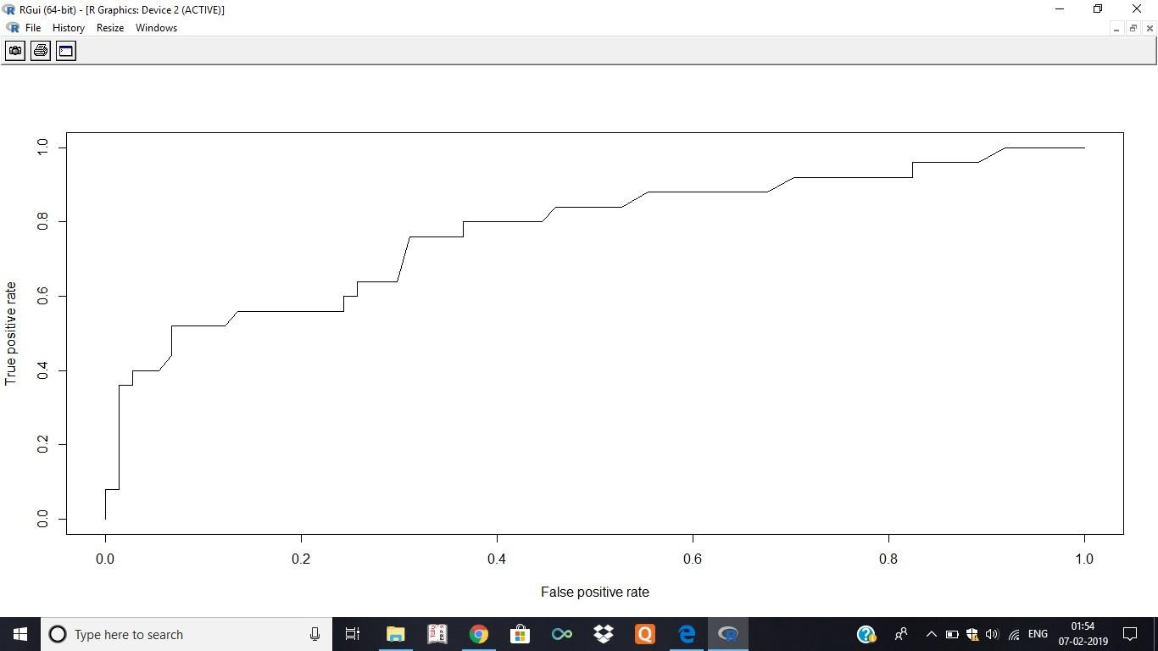

lowess

Warning messages:

1: package ‘ROCR’ was built under R version 3.5.2

**2: package ‘gplots’ was built under R version 3.5.2**

* ROCRpred = prediction(predictTrain, qualityTrain$PoorCare)
* ROCRperf = performance(ROCRpred, "tpr", "fpr")
* plot(ROCRperf)
* plot(ROCRperf, colorize=TRUE)
* plot(ROCRperf, colorize=TRUE, print.cutoffs.at=seq(0,1,by=0.1), text.adj=c(-0.2,1.7))
* ​

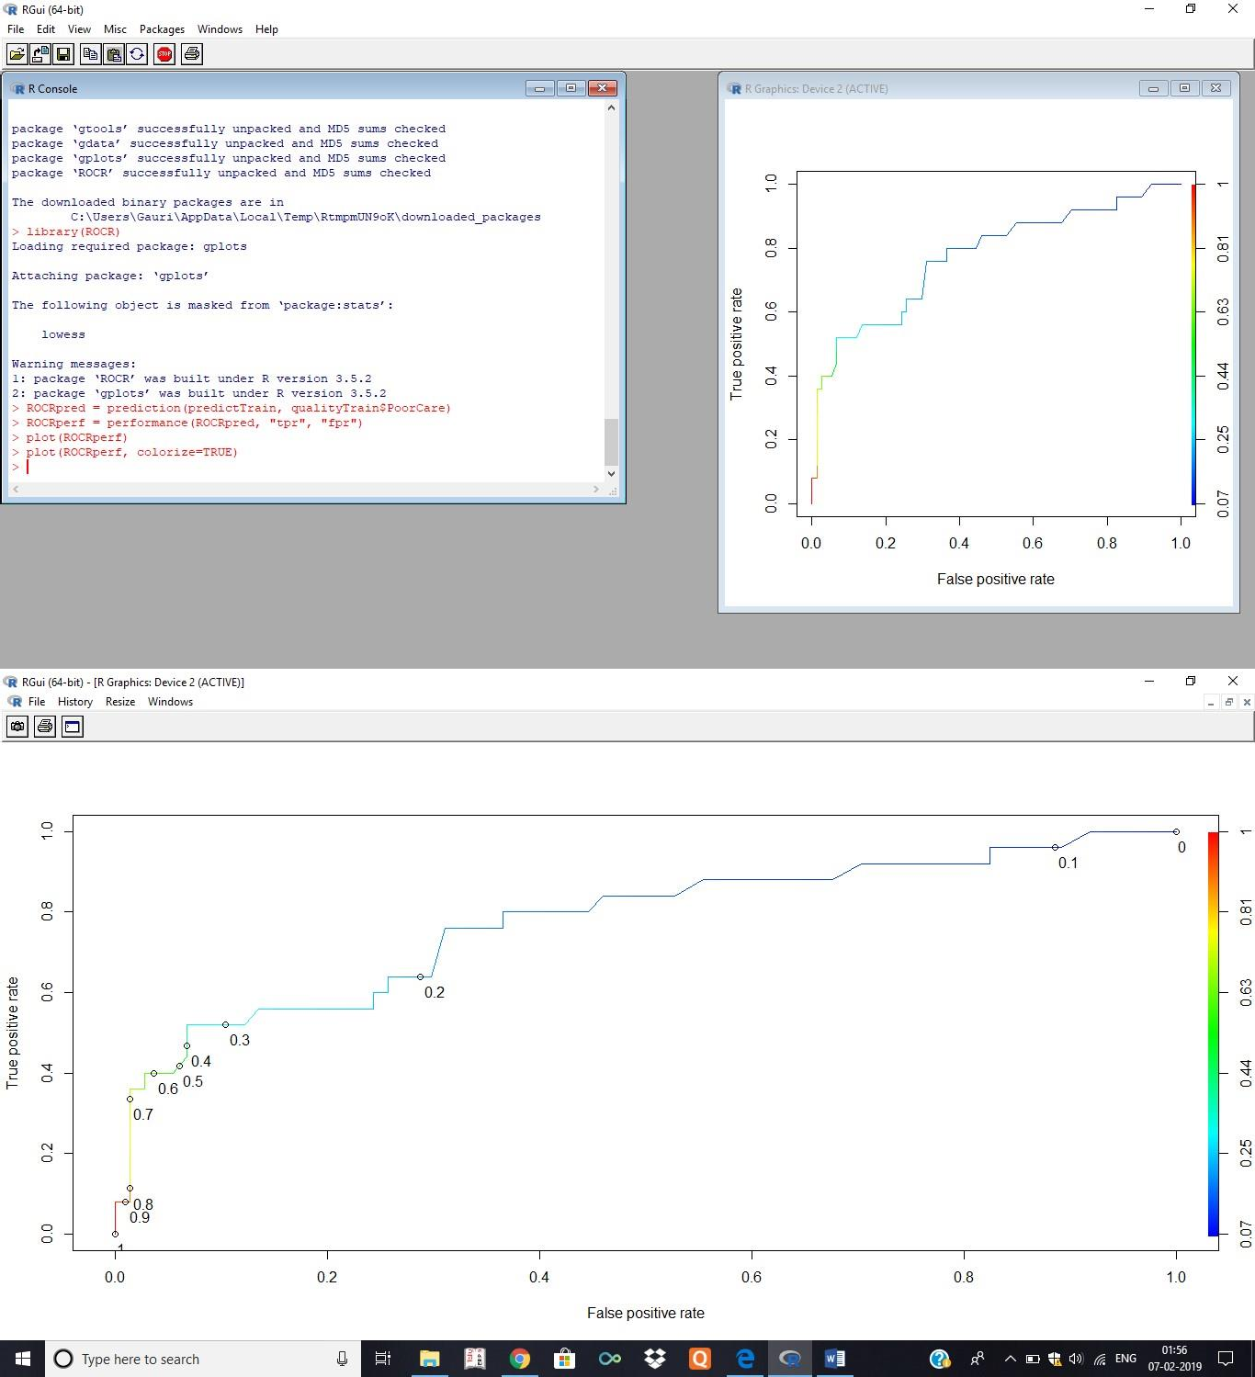

**Learning Outcomes:**

**Course Outcomes:**

**Conclusion:**

**Viva Questions:**

1. **Define logistic regression.**
2. **Purpose of the logit function?**
3. **Outcome variable type?**
4. **Example use case?**

**For Faculty use:**

|  |  |  |  |
| --- | --- | --- | --- |
| Correction Parameters | Formative Assessment[40%] | Timely Completion of Practical[40%] | Attendance Learning Attitude[20%] |